UNITED STATES
SECURITIES AND EXCHANGE COMMISSION
Washington, D.C. 20549

SCHEDULE 14A INFORMATION
Proxy Statement Pursuant to Section 14(a) of the Securities Exchange Act of 1934
(Amendment No. )

Filed by the Registrant ☒ |  | Filed by a Party other than the Registrant ☐
Check the appropriate box:
☐ | Preliminary Proxy Statement
☐ | Confidential, for Use of the Commission Only (as permitted by Rule 14a-6(e)(2))
☐ | Definitive Proxy Statement
☒ | Definitive Additional Materials
☐ | Soliciting Material Pursuant to §240. 14a-12

FULCRUM THERAPEUTICS, INC.

(Name of Registrant as Specified in Its Charter)
(Name of Person(s) Filing Proxy Statement, if other than the Registrant)
Payment of Filing Fee (Check all boxes that apply):

☒ | No fee required.
☐ | Fee paid previously with preliminary materials.
☐ | Fee computed on table in exhibit required by Item 25(b) per Exchange Act Rules 14a-6(i)(1) and 0-11

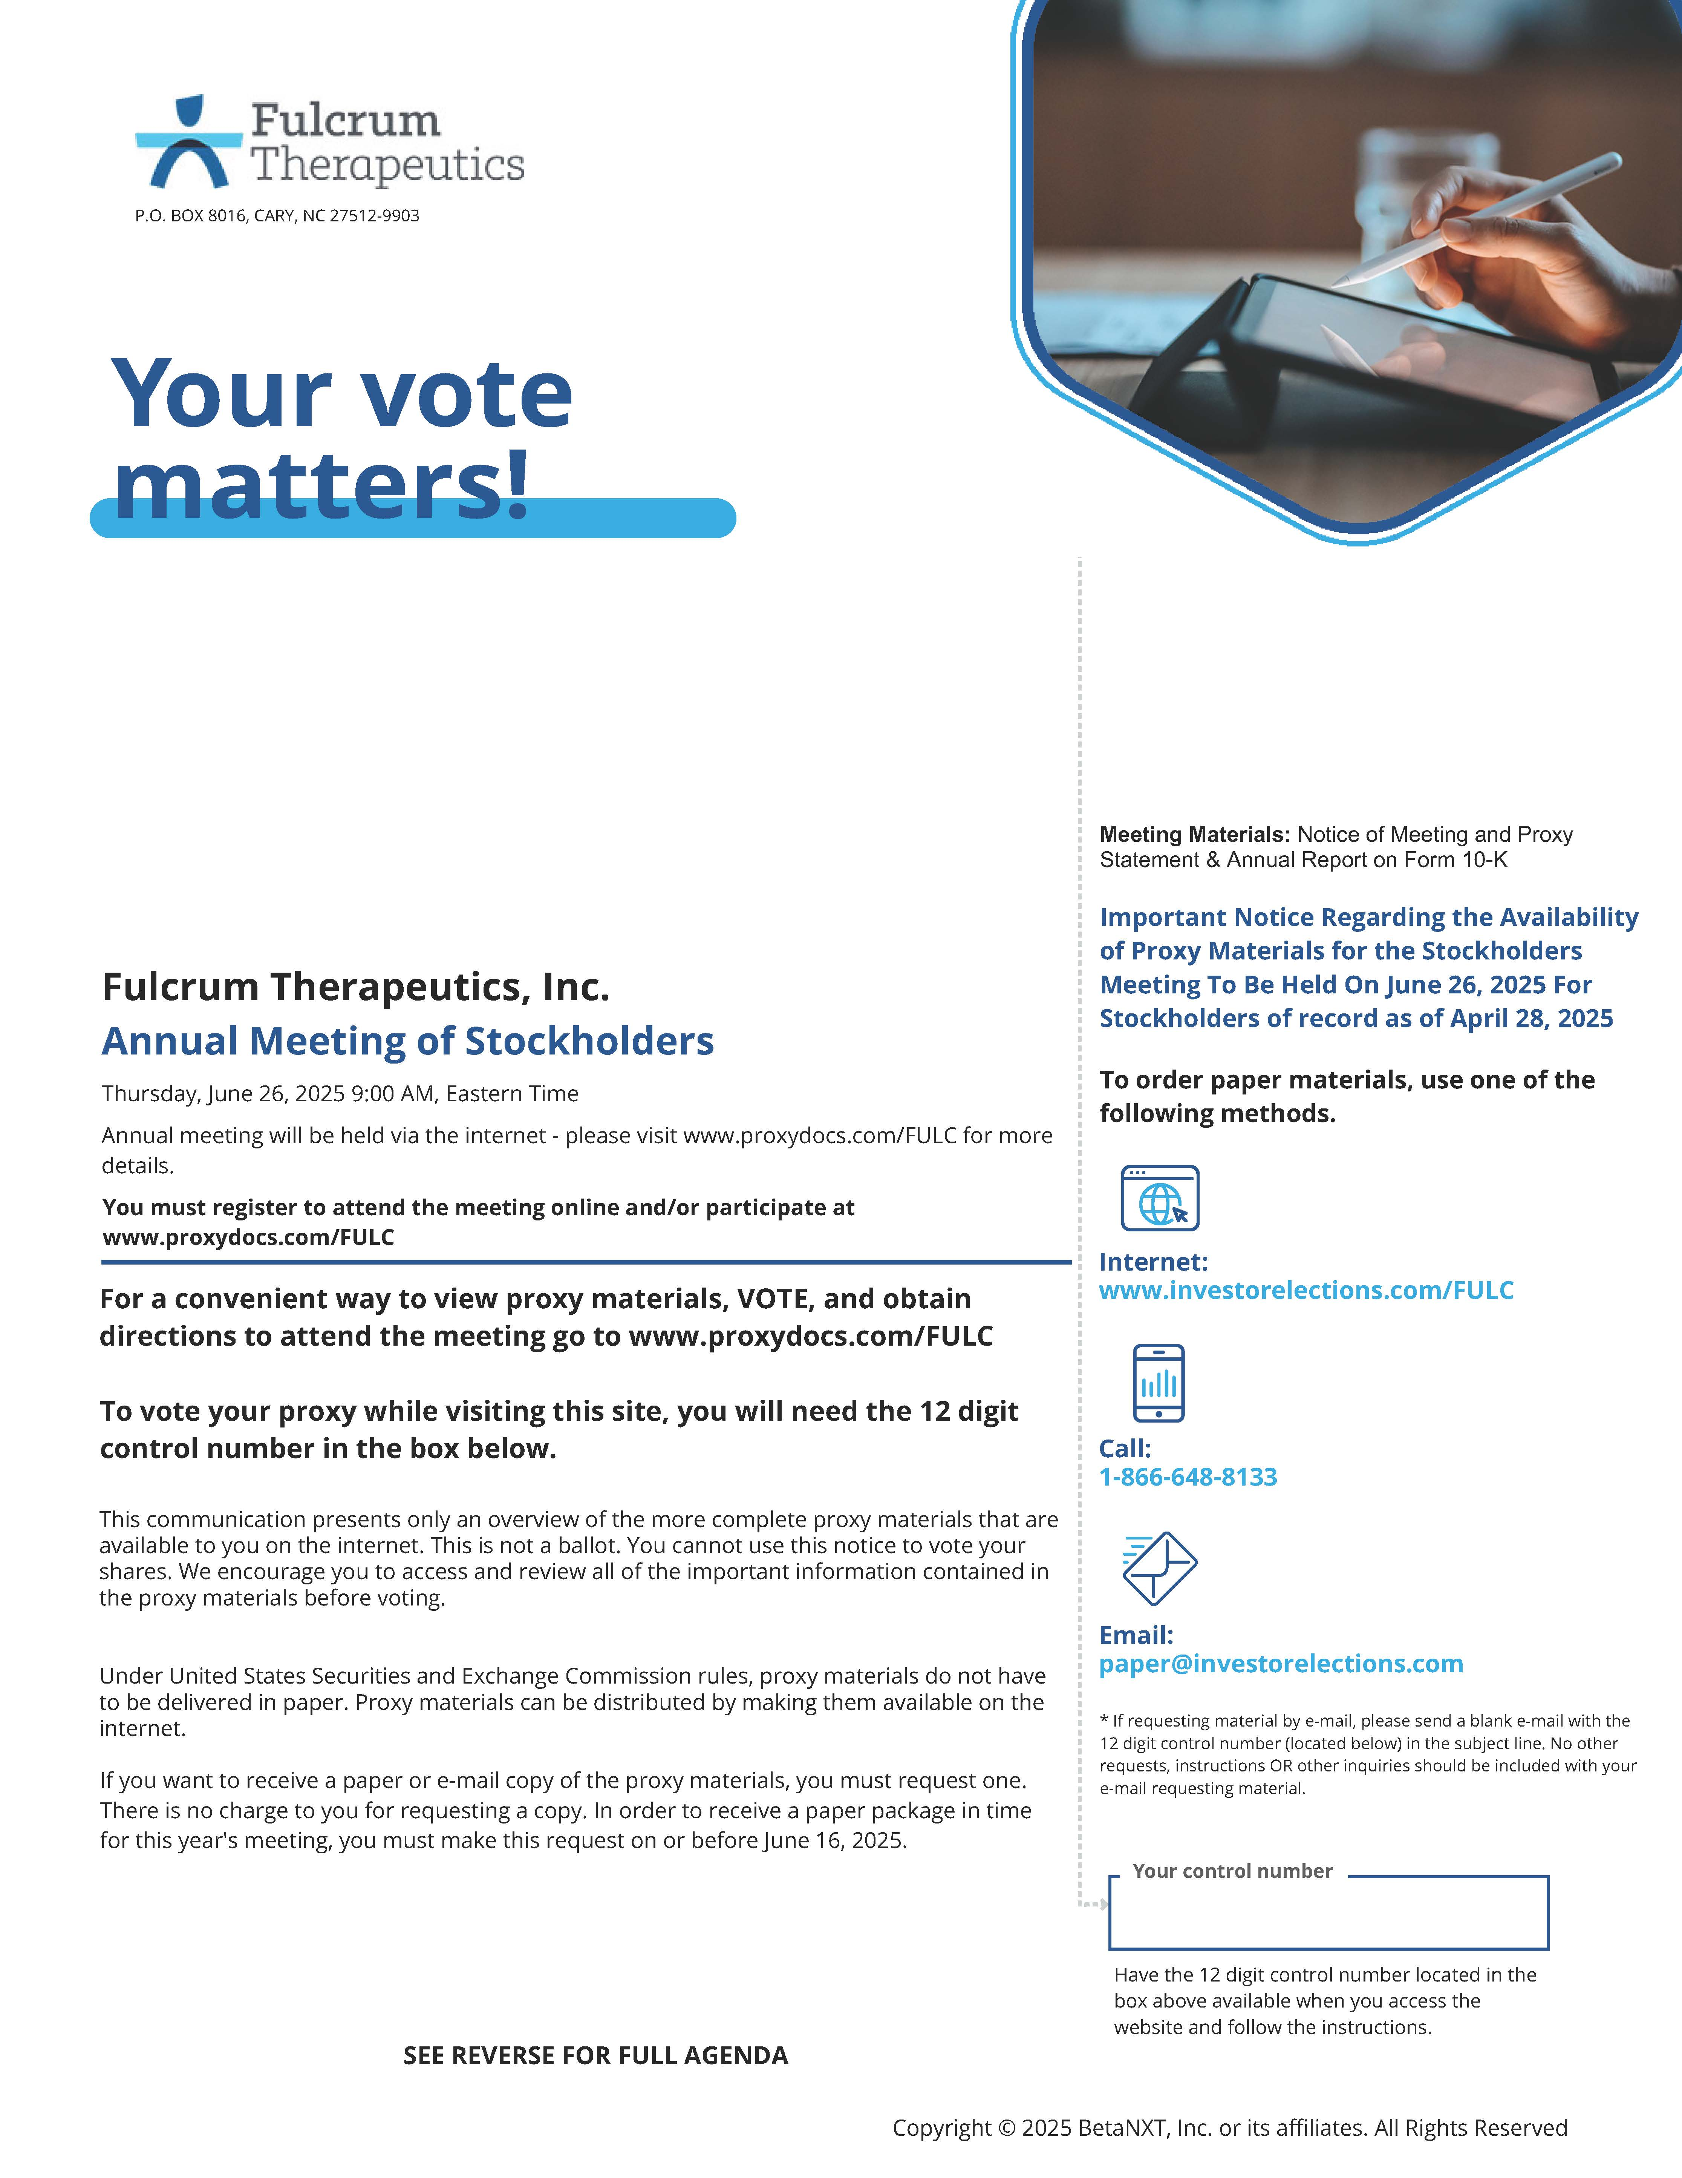

Fulcrum Therapeutics P.O. BOX 8016, CARY, NC 27512-9903 Your vote matters! Fulcrum Therapeutics, Inc. Annual Meeting of Stockholders Thursday, June 26, 2025 9:00 AM, Eastern Time Annual meeting will be held via the internet - please visit www.proxydocs.com/FULC for more details. You must register to attend the meeting online and/or participate at www.proxydocs.com/FULC For a convenient way to view proxy materials, VOTE, and obtain directions to attend the meeting go to www.proxydocs.com/FULC To vote your proxy while visiting this site, you will need the 12 digit control number in the box below. This communication presents only an overview of the more complete proxy materials that are available to you on the internet. This is not a ballot. You cannot use this notice to vote your shares. We encourage you to access and review all of the important information contained in the proxy materials before voting. Under United States Securities and Exchange Commission rules, proxy materials do not have to be delivered in paper. Proxy materials can be distributed by making them available on the internet. If you want to receive a paper or e-mail copy of the proxy materials, you must request one. There is no charge to you for requesting a copy. In order to receive a paper package in time for this year's meeting, you must make this request on or before June 16, 2025. Meeting Materials: Notice of Meeting and Proxy Statement & Annual Report on Form 10-K Important Notice Regarding the Availability of Proxy Materials for the Stockholders Meeting To Be Held On June 26, 2025 For Stockholders of record as of April 28, 2025 To order paper materials, use one of the following methods. Internet: www.investorelections.com/FULC Call: 1-866-648-8133 Email: paper@investorelections.com * If requesting material by e-mail, please send a blank e-mail with the 12 digit control number (located below) in the subject line. No other requests, instructions OR other inquiries should be included with your e-mail requesting material. Your control number Have the 12 digit control number located in the box above available when you access the website and follow the instructions. SEE REVERSE FOR FULL AGENDA Copyright © 2025 BetaNXT, Inc. or its affiliates. All Rights Reserved

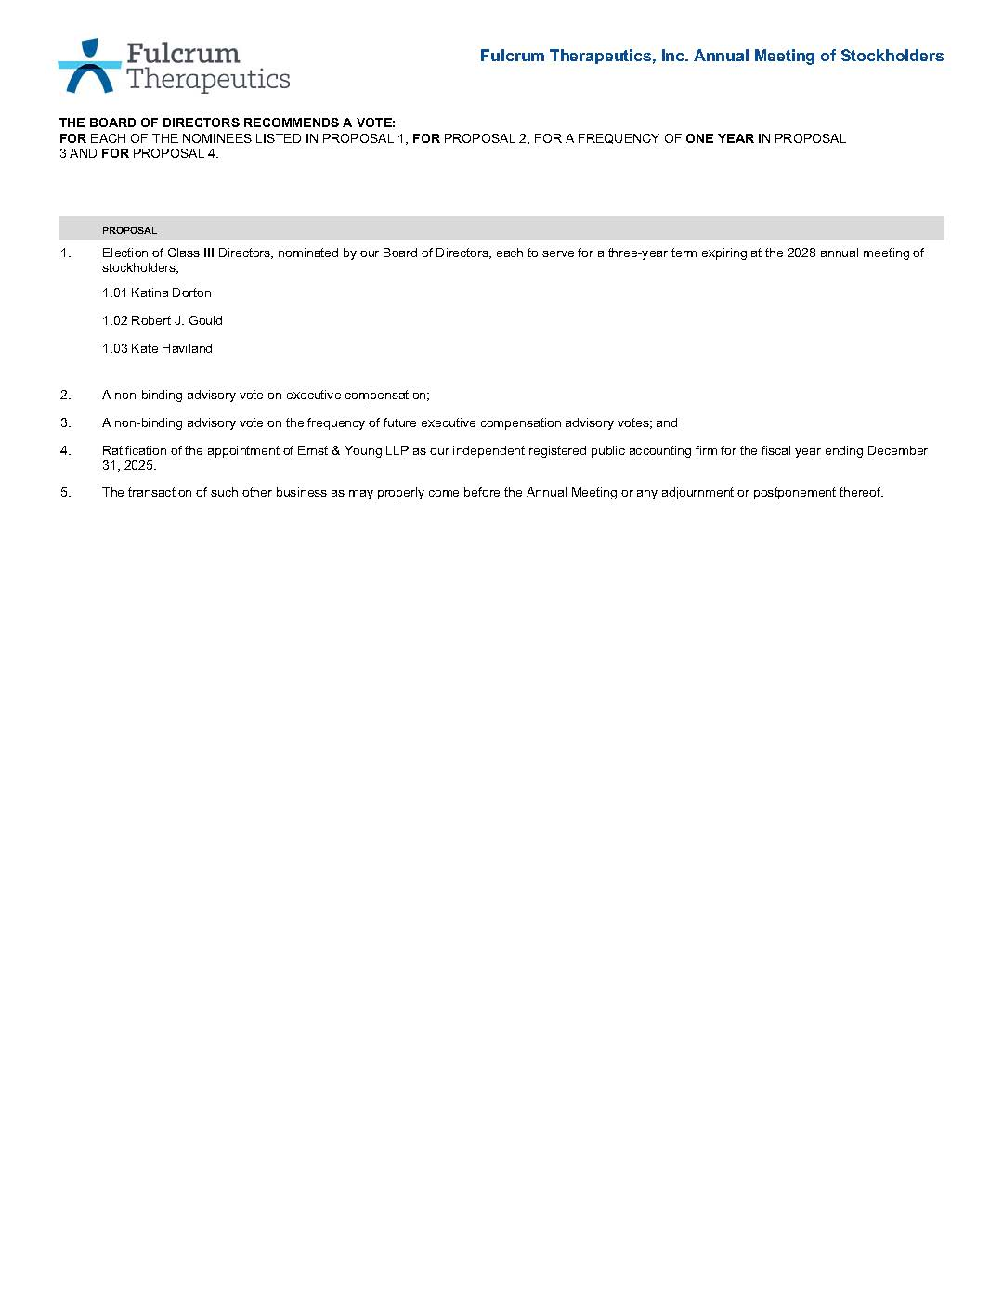

Fulcrum Therapeutics THE BOARD OF DIRECTORS RECOMMENDS A VOTE: FOR EACH OF THE NOMINEES LISTED IN PROPOSAL 1, FOR PROPOSAL 2, FOR A FREQUENCY OF ONE YEAR IN PROPOSAL 3 AND FOR PROPOSAL 4. Fulcrum Therapeutics, Inc. Annual Meeting of Stockholders PROPOSAL 1. Election of Class III Directors, nominated by our Board of Directors, each to serve for a three-year term expiring at the 2028 annual meeting of stockholders; 1.01 Katina Dorton 1.02 Robert J. Gould 1.03 Kate Haviland 2. A non-binding advisory vote on executive compensation; 3. A non-binding advisory vote on the frequency of future executive compensation advisory votes; and 4. Ratification of the appointment of Ernst & Young LLP as our independent registered public accounting firm for the fiscal year ending December 31, 2025. 5. The transaction of such other business as may properly come before the Annual Meeting or any adjournment or postponement thereof.

