UNITED STATES
SECURITIES AND EXCHANGE COMMISSION
Washington, D.C. 20549

SCHEDULE 14A INFORMATION
Proxy Statement Pursuant to Section 14(a) of the
Securities Exchange Act of 1934
(Amendment No. )

Filed by the Registrant ☒ Filed by a Party other than the Registrant ☐
Check the appropriate box:

☐ |  | Preliminary Proxy Statement
☐ |  | Confidential, for Use of the Commission Only (as permitted by Rule 14a-6(e)(2))
☐ |  | Definitive Proxy Statement
☒ |  | Definitive Additional Materials
☐ |  | Soliciting Material Pursuant to §240. 14a-12
FULCRUM THERAPEUTICS, INC.
(Name of Registrant as Specified in Its Charter)

(Name of Person(s) Filing Proxy Statement, if other than the Registrant)
Payment of Filing Fee (Check all boxes that apply):
☒ |  | No fee required.
☐ |  | Fee paid previously with preliminary materials.
☐ |  | Fee computed on table in exhibit required by Item 25(b) per Exchange Act Rules 14a-6(i)(1) and 0-11

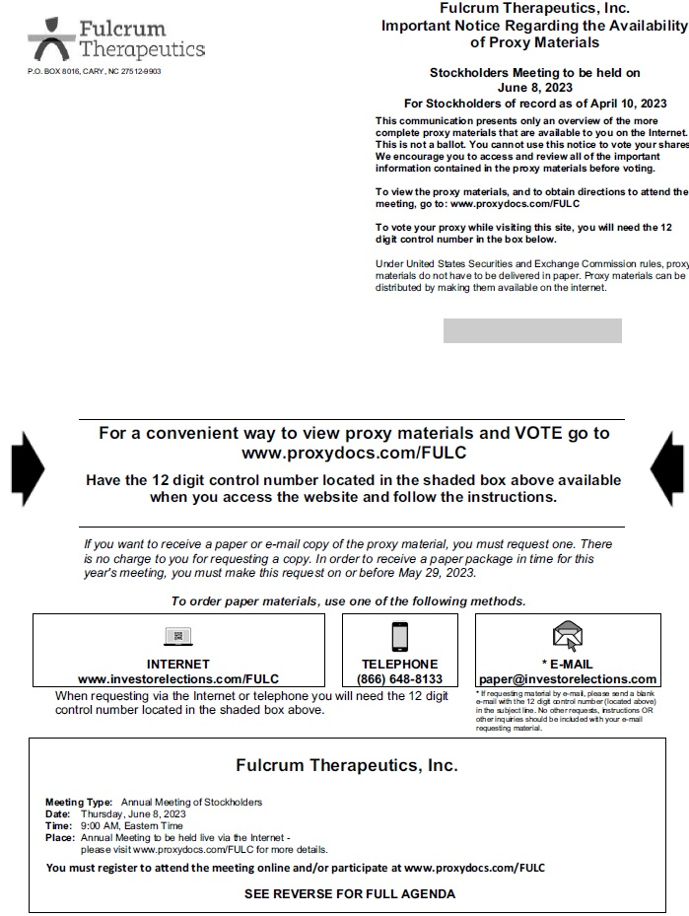
Fulcrum Therapeutics, Inc. Important Notice Regarding the Availability of Proxy Materials P.O. BOX 8016, CARY, NC 27512-9903 Stockholders Meeting to be held on June 8, 2023 For Stockholders of record as of April 10, 2023 This communication presents only an overview of the more complete proxy materials that are available to you on the Internet This is not a ballot. You cannot use this notice to vote your shares We encourage you to access and review all of the important information contained in the proxy materials before voting. To view the proxy materials, and to obtain directions to attend the meeting, go to: www.proxydocs.com/FULC To vote your proxy while visiting this site, you will need the 12 digit control number in the box below. Under United States Securities and Exchange Commission rules, proxy materials do not have to be delivered in paper. Proxy materials can be distributed by making them available on the internet. For a convenient way to view proxy materials and VOTE go to www.proxydocs.com/FULC Have the 12 digit control number located in the shaded box above available when you access the website and follow the instructions. If you want to receive a paper or e-mail copy of the proxy material, you must request one. There is no charge to you for requesting a copy. In order to receive a paper package in time for this years meeting, you must make this request on or before May 29, 2023. To order paper materials, use one of the following methods. INTERNET TELEPHONE * E-MAIL www.investorelections.com/FULC (866) 648-8133 paper@investorelections.com When requesting via the Internet or telephone you will need the 12 digit * If requesting material by e-mail, please send a blank e-mail with the 12 digit control number (located above) control number located in the shaded box above. in the subject line. No other requests, instructions OR other inquiries should be included with your e-mail requesting material. Fulcrum Therapeutics, Inc. Meeting Type: Annual Meeting of Stockholders Date: Thursday, June 8, 2023 Time: 9:00 AM, Eastern Time Place: Annual Meeting to be held live via the Internet - please visit www.proxydocs.com/FULC for more details. You must register to attend the meeting online and/or participate at www.proxydocs.com/FULC SEE REVERSE FOR FULL AGENDA

Fulcrum Therapeutics, Inc. Annual Meeting of Stockholders FOR EACH OF THE NOMINEES LISTED IN PROPOSAL 1, FOR PROPOSAL 2, FOR PROPOSAL 3, AND FOR PROPOSAL 4. PROPOSAL 1. To elect two Class I directors named below to a 3-year term expiring at the 2026 annual meeting of stockholders. 1.01 Alan Ezekowitz 1.02 Sonja Banks 2. To approve an amendment to the Companys 2019 Stock Incentive Plan to modify the automatic increase to the share reserve provision. 3. To approve an amendment to the Companys Restated Certificate of Incorporation to limit the liability of certain Company officers as permitted by recent amendments to Delaware law. 4. To ratify the appointment of Ernst & Young as the independent registered public accounting firm for the Company for the fiscal year ending December 31, 2023. 5. To consider and act upon such other business as may properly come before the meeting or any adjournment or postponement thereof.

