UNITED STATES
SECURITIES AND EXCHANGE COMMISSION
Washington, D.C. 20549

FORM 8-K

CURRENT REPORT
Pursuant to Section 13 OR 15(d) of The Securities Exchange Act of 1934
Date of Report (Date of earliest event reported): January 12, 2026

Fulcrum Therapeutics, Inc.
(Exact name of registrant as specified in its charter)

Delaware |  |  | 001-38978 | 47-4839948
(State or other jurisdiction  of incorporation) |  |  | (Commission File Number) | (IRS Employer  Identification No.)
26 Landsdowne Street
Cambridge, Massachusetts |  |  |  | 02139
(Address of principal executive offices) |  |  |  | (Zip Code)

Registrant’s telephone number, including area code: (617) 651-8851

N/A
(Former name or former address, if changed since last report)

Check the appropriate box below if the Form 8-K filing is intended to simultaneously satisfy the filing obligation of the registrant under any of the following provisions:
☐Written communications pursuant to Rule 425 under the Securities Act (17 CFR 230.425)
☐Soliciting material pursuant to Rule 14a-12 under the Exchange Act (17 CFR 240.14a-12)
☐Pre-commencement communications pursuant to Rule 14d-2(b) under the Exchange Act (17 CFR 240.14d-2(b))
☐Pre-commencement communications pursuant to Rule 13e-4(c) under the Exchange Act (17 CFR 240.13e-4(c))
Securities registered pursuant to Section 12(b) of the Act:
Title of each class |  | Trading  Symbol(s) |  | Name of each exchange on which registered
Common stock, par value $0.001 per share |  | FULC |  | Nasdaq Global Market
Indicate by check mark whether the registrant is an emerging growth company as defined in Rule 405 of the Securities Act of 1933 (§ 230.405 of this chapter) or Rule 12b-2 of the Securities Exchange Act of 1934 (§ 240.12b-2 of this chapter).
Emerging growth company ☐
If an emerging growth company, indicate by check mark if the registrant has elected not to use the extended transition period for complying with any new or revised financial accounting standards provided pursuant to Section 13(a) of the Exchange Act. ☐

Item 2.02 Results of Operations and Financial Condition.
Fulcrum Therapeutics, Inc., or Fulcrum, expects to report that it had cash, cash equivalents and marketable securities of approximately $352.3 million as of December 31, 2025.
The estimated cash figure is preliminary and unaudited, represents a management estimate as of the date of this Current Report on Form 8-K and is subject to completion of Fulcrum's financial closing procedures. Fulcrum's independent registered public accounting firm has not conducted an audit or review of, and does not express an opinion or any other form of assurance with respect to, the estimated cash figure.
The information in Item 2.02 of this Current Report on Form 8-K is intended to be furnished and shall not be deemed “filed” for purposes of Section 18 of the Securities Exchange Act of 1934, as amended, or the Exchange Act, or otherwise subject to the liabilities of that section, nor shall it be deemed incorporated by reference in any filing under the Securities Act of 1933, as amended, or the Exchange Act, except as expressly set forth by specific reference in such filing.

Item 7.01 Regulation FD Disclosure.
On January 12, 2026, Fulcrum updated its corporate presentation to reflect certain business and strategic updates. Fulcrum intends to use this presentation in meetings with members of the investment community and others from time to time, including its presentation by management at the 44th Annual J.P. Morgan Healthcare Conference on January 14, 2026 at 7:30 a.m. PT (10:30 a.m. ET). A live webcast of the presentation and will be available on the “Events and Presentations” section of Fulcrum's website at https://ir.fulcrumtx.com. A copy of the presentation is attached as Exhibit 99.1 to this Current Report on Form 8-K and is incorporated by reference herein.
The information in Item 7.01 of this Current Report on Form 8-K, including Exhibit 99.1 attached hereto, is intended to be furnished and shall not be deemed “filed” for purposes of Section 18 of the Exchange Act, or otherwise subject to the liabilities of that section, nor shall it be deemed incorporated by reference in any filing under the Securities Act, except as expressly set forth by specific reference in such filing.

Item 9.01 Financial Statements and Exhibits.
(d) Exhibits
The following exhibit is furnished herewith:

99.1 | Corporate slide presentation of Fulcrum Therapeutics, Inc. dated January 12, 2026
104 | Cover Page Interactive Data File (embedded within the Inline XBRL document)

SIGNATURES
Pursuant to the requirements of the Securities Exchange Act of 1934, the registrant has duly caused this report to be signed on its behalf by the undersigned hereunto duly authorized.
 |  |  | FULCRUM THERAPEUTICS, INC.
Date: | January 12, 2026 | By: | /s/ Alex C. Sapir
Name: Alex C. Sapir
Title: President and Chief Executive Officer


January 2026

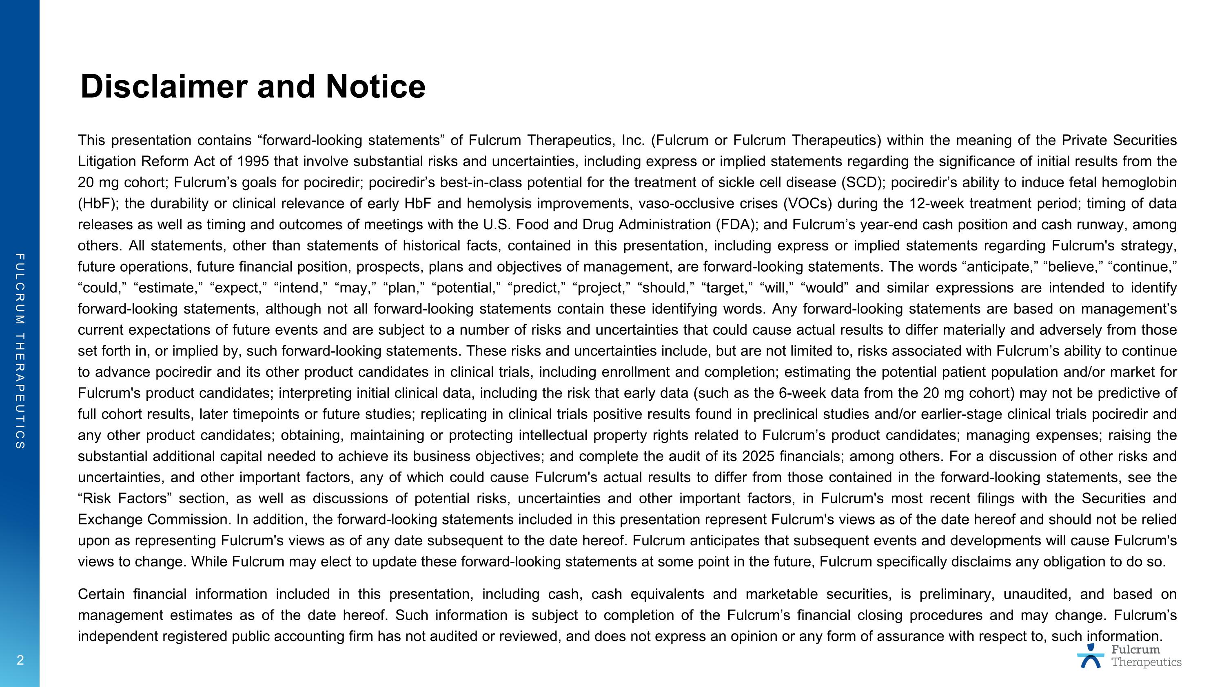
Disclaimer and Notice This presentation contains “forward-looking statements” of Fulcrum Therapeutics, Inc. (Fulcrum or Fulcrum Therapeutics) within the meaning of the Private Securities Litigation Reform Act of 1995 that involve substantial risks and uncertainties, including express or implied statements regarding the significance of initial results from the 20 mg cohort; Fulcrum’s goals for pociredir; pociredir’s best-in-class potential for the treatment of sickle cell disease (SCD); pociredir’s ability to induce fetal hemoglobin (HbF); the durability or clinical relevance of early HbF and hemolysis improvements, vaso-occlusive crises (VOCs) during the 12-week treatment period; timing of data releases as well as timing and outcomes of meetings with the U.S. Food and Drug Administration (FDA); and Fulcrum’s year-end cash position and cash runway, among others. All statements, other than statements of historical facts, contained in this presentation, including express or implied statements regarding Fulcrum's strategy, future operations, future financial position, prospects, plans and objectives of management, are forward-looking statements. The words “anticipate,” “believe,” “continue,” “could,” “estimate,” “expect,” “intend,” “may,” “plan,” “potential,” “predict,” “project,” “should,” “target,” “will,” “would” and similar expressions are intended to identify forward-looking statements, although not all forward-looking statements contain these identifying words. Any forward-looking statements are based on management’s current expectations of future events and are subject to a number of risks and uncertainties that could cause actual results to differ materially and adversely from those set forth in, or implied by, such forward-looking statements. These risks and uncertainties include, but are not limited to, risks associated with Fulcrum’s ability to continue to advance pociredir and its other product candidates in clinical trials, including enrollment and completion; estimating the potential patient population and/or market for Fulcrum's product candidates; interpreting initial clinical data, including the risk that early data (such as the 6-week data from the 20 mg cohort) may not be predictive of full cohort results, later timepoints or future studies; replicating in clinical trials positive results found in preclinical studies and/or earlier-stage clinical trials pociredir and any other product candidates; obtaining, maintaining or protecting intellectual property rights related to Fulcrum’s product candidates; managing expenses; raising the substantial additional capital needed to achieve its business objectives; and complete the audit of its 2025 financials; among others. For a discussion of other risks and uncertainties, and other important factors, any of which could cause Fulcrum's actual results to differ from those contained in the forward-looking statements, see the “Risk Factors” section, as well as discussions of potential risks, uncertainties and other important factors, in Fulcrum's most recent filings with the Securities and Exchange Commission. In addition, the forward-looking statements included in this presentation represent Fulcrum's views as of the date hereof and should not be relied upon as representing Fulcrum's views as of any date subsequent to the date hereof. Fulcrum anticipates that subsequent events and developments will cause Fulcrum's views to change. While Fulcrum may elect to update these forward-looking statements at some point in the future, Fulcrum specifically disclaims any obligation to do so. Certain financial information included in this presentation, including cash, cash equivalents and marketable securities, is preliminary, unaudited, and based on management estimates as of the date hereof. Such information is subject to completion of the Fulcrum’s financial closing procedures and may change. Fulcrum’s independent registered public accounting firm has not audited or reviewed, and does not express an opinion or any form of assurance with respect to, such information.

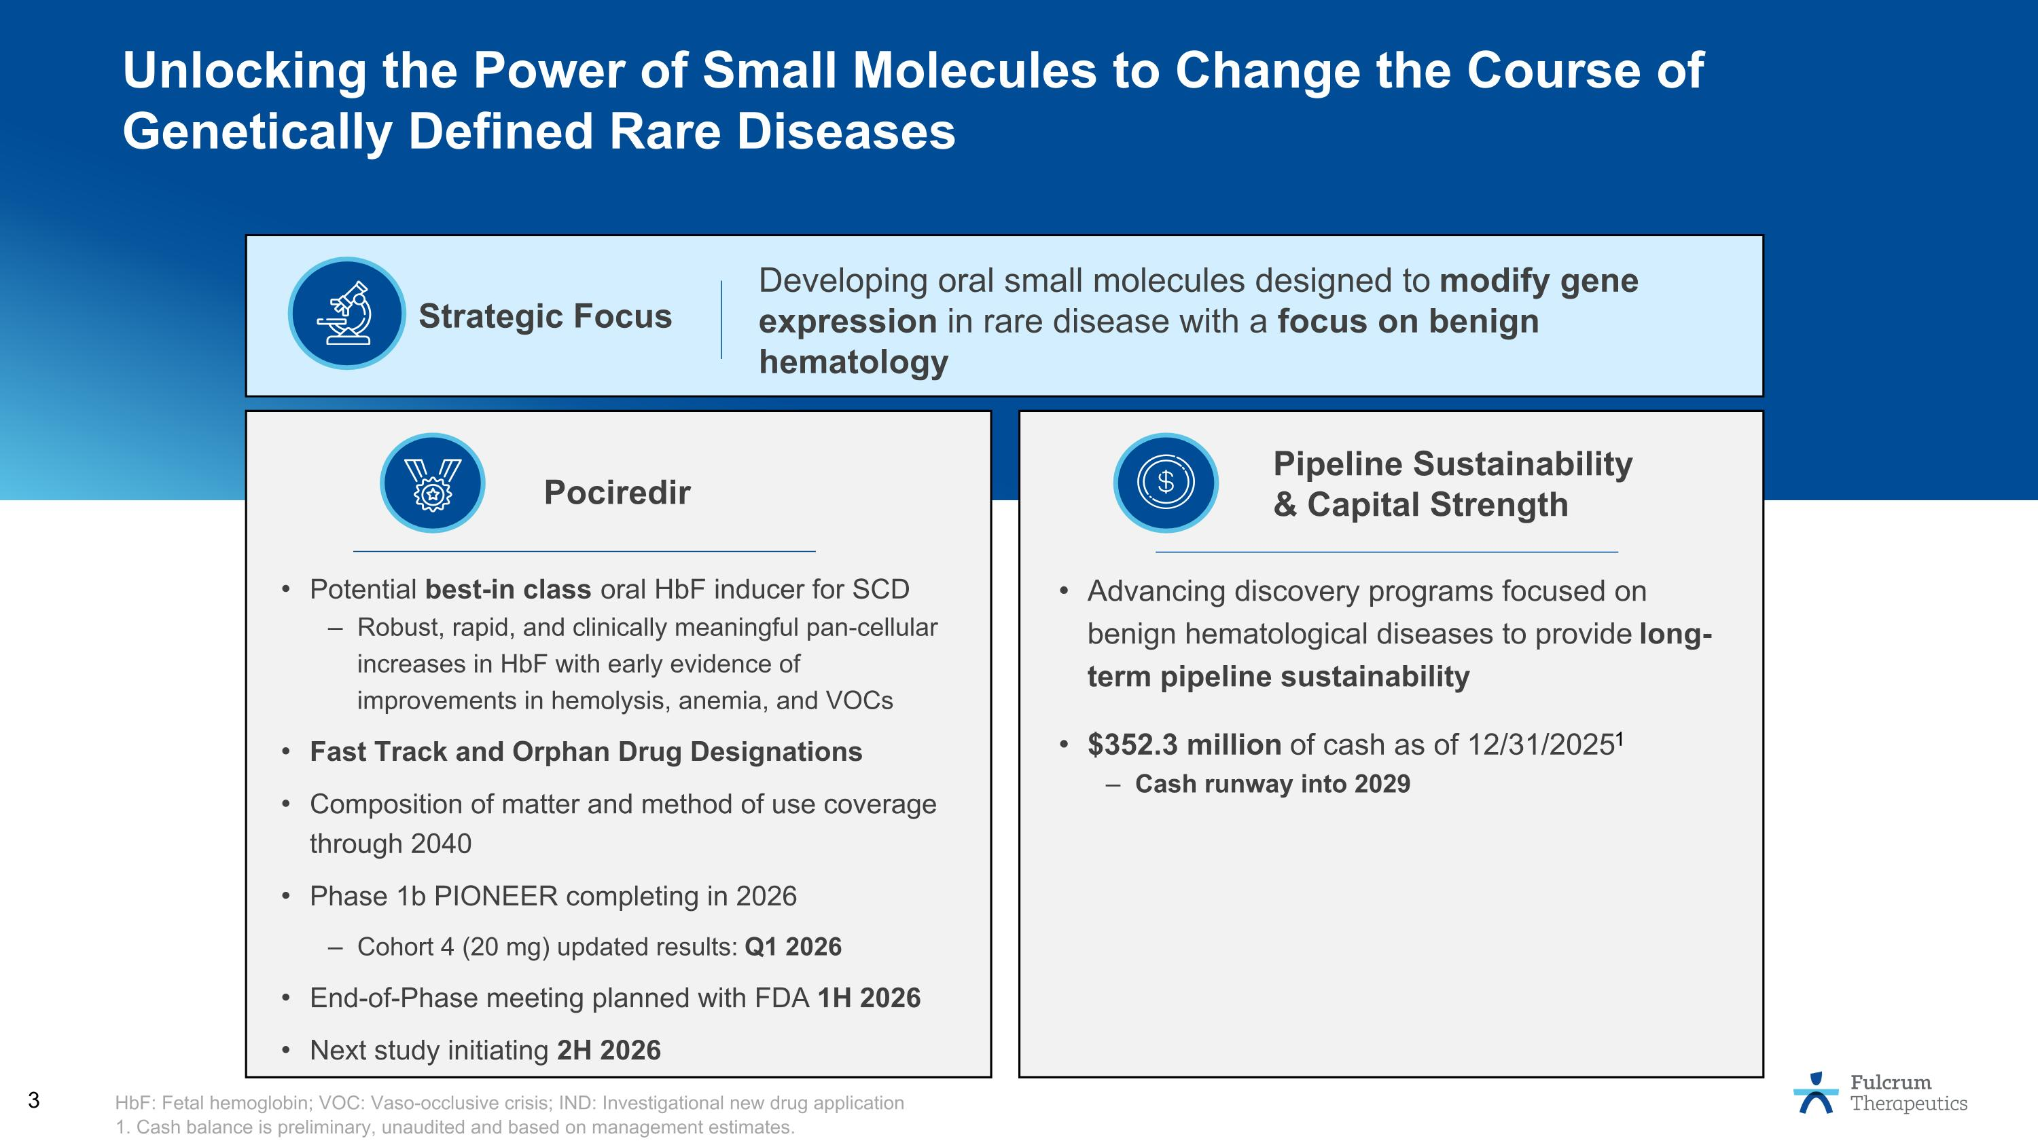
Potential best-in class oral HbF inducer for SCD Robust, rapid, and clinically meaningful pan-cellular increases in HbF with early evidence of improvements in hemolysis, anemia, and VOCs Fast Track and Orphan Drug Designations Composition of matter and method of use coverage through 2040 Phase 1b PIONEER completing in 2026 Cohort 4 (20 mg) updated results: Q1 2026 End-of-Phase meeting planned with FDA 1H 2026 Next study initiating 2H 2026 Advancing discovery programs focused on benign hematological diseases to provide long-term pipeline sustainability $352.3 million of cash as of 12/31/20251 Cash runway into 2029 Pociredir Pipeline Sustainability & Capital Strength HbF: Fetal hemoglobin; VOC: Vaso-occlusive crisis; IND: Investigational new drug application 1. Cash balance is preliminary, unaudited and based on management estimates. Unlocking the Power of Small Molecules to Change the Course of Genetically Defined Rare Diseases Strategic Focus Developing oral small molecules designed to modify gene expression in rare disease with a focus on benign hematology

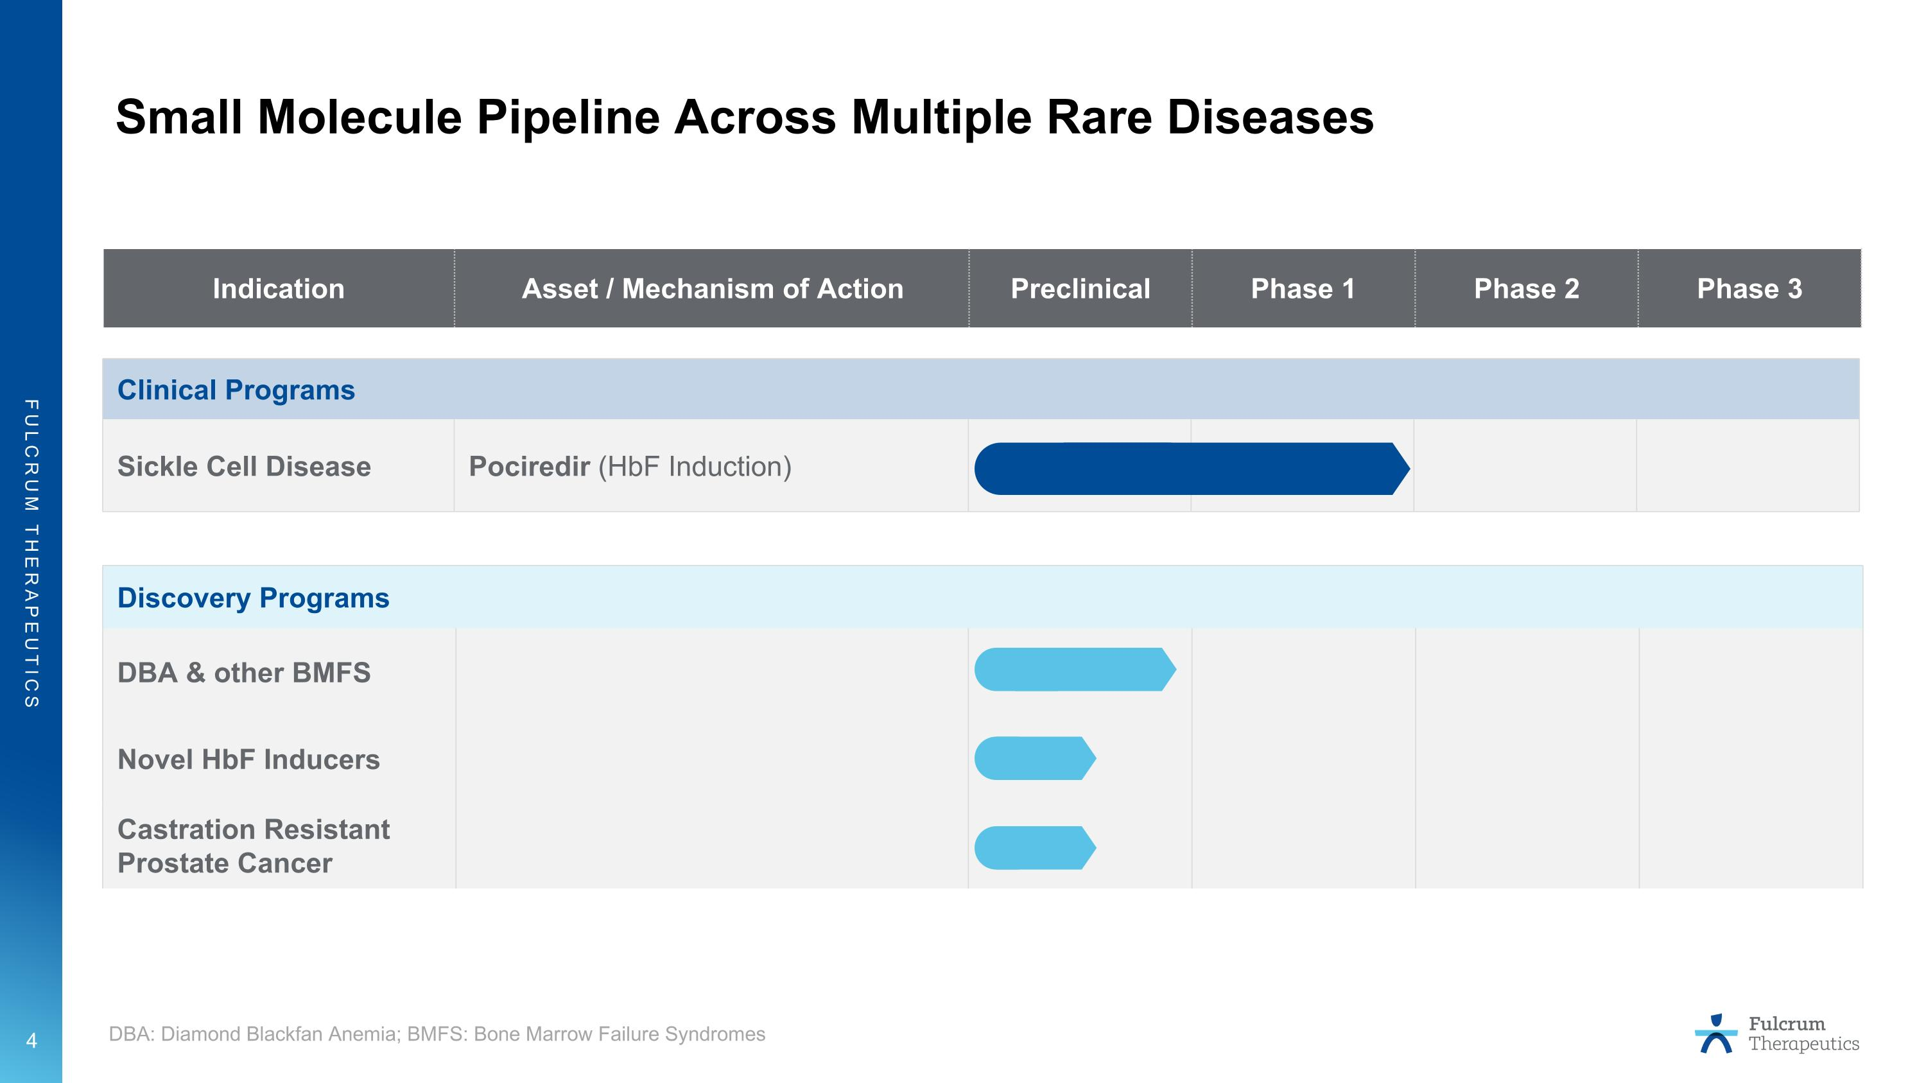
Small Molecule Pipeline Across Multiple Rare Diseases Indication Asset / Mechanism of Action Preclinical Phase 1 Phase 2 Phase 3 Clinical Programs Sickle Cell Disease Pociredir (HbF Induction) Discovery Programs DBA & other BMFS Novel HbF Inducers Castration Resistant Prostate Cancer DBA: Diamond Blackfan Anemia; BMFS: Bone Marrow Failure Syndromes


Pociredir for Sickle Cell Disease Fast Track Designation Orphan Drug Designation

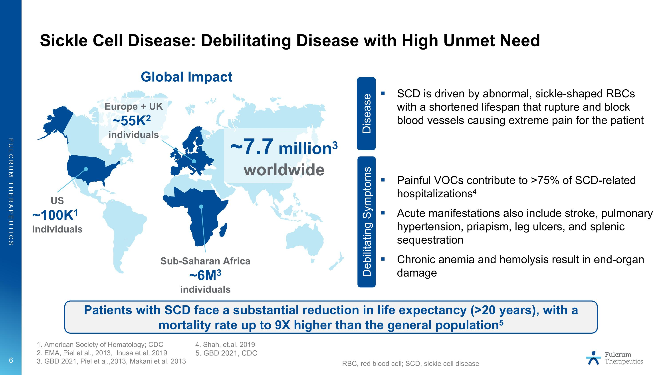
Sickle Cell Disease: Debilitating Disease with High Unmet Need SCD is driven by abnormal, sickle-shaped RBCs with a shortened lifespan that rupture and block blood vessels causing extreme pain for the patient Painful VOCs contribute to >75% of SCD-related hospitalizations4 Acute manifestations also include stroke, pulmonary hypertension, priapism, leg ulcers, and splenic sequestration Chronic anemia and hemolysis result in end-organ damage 1. American Society of Hematology; CDC 2. EMA, Piel et al., 2013, Inusa et al. 2019 3. GBD 2021, Piel et al.,2013, Makani et al. 2013 US ~100K1 ?individuals Sub-Saharan Africa ~6M3?individuals Global Impact ~7.7 million3 worldwide Europe + UK ~55K2 ?individuals Disease Debilitating Symptoms Patients with SCD face a substantial reduction in life expectancy (>20 years), with a mortality rate up to 9X higher than the general population5 RBC, red blood cell; SCD, sickle cell disease 4. Shah, et.al. 2019 5. GBD 2021, CDC

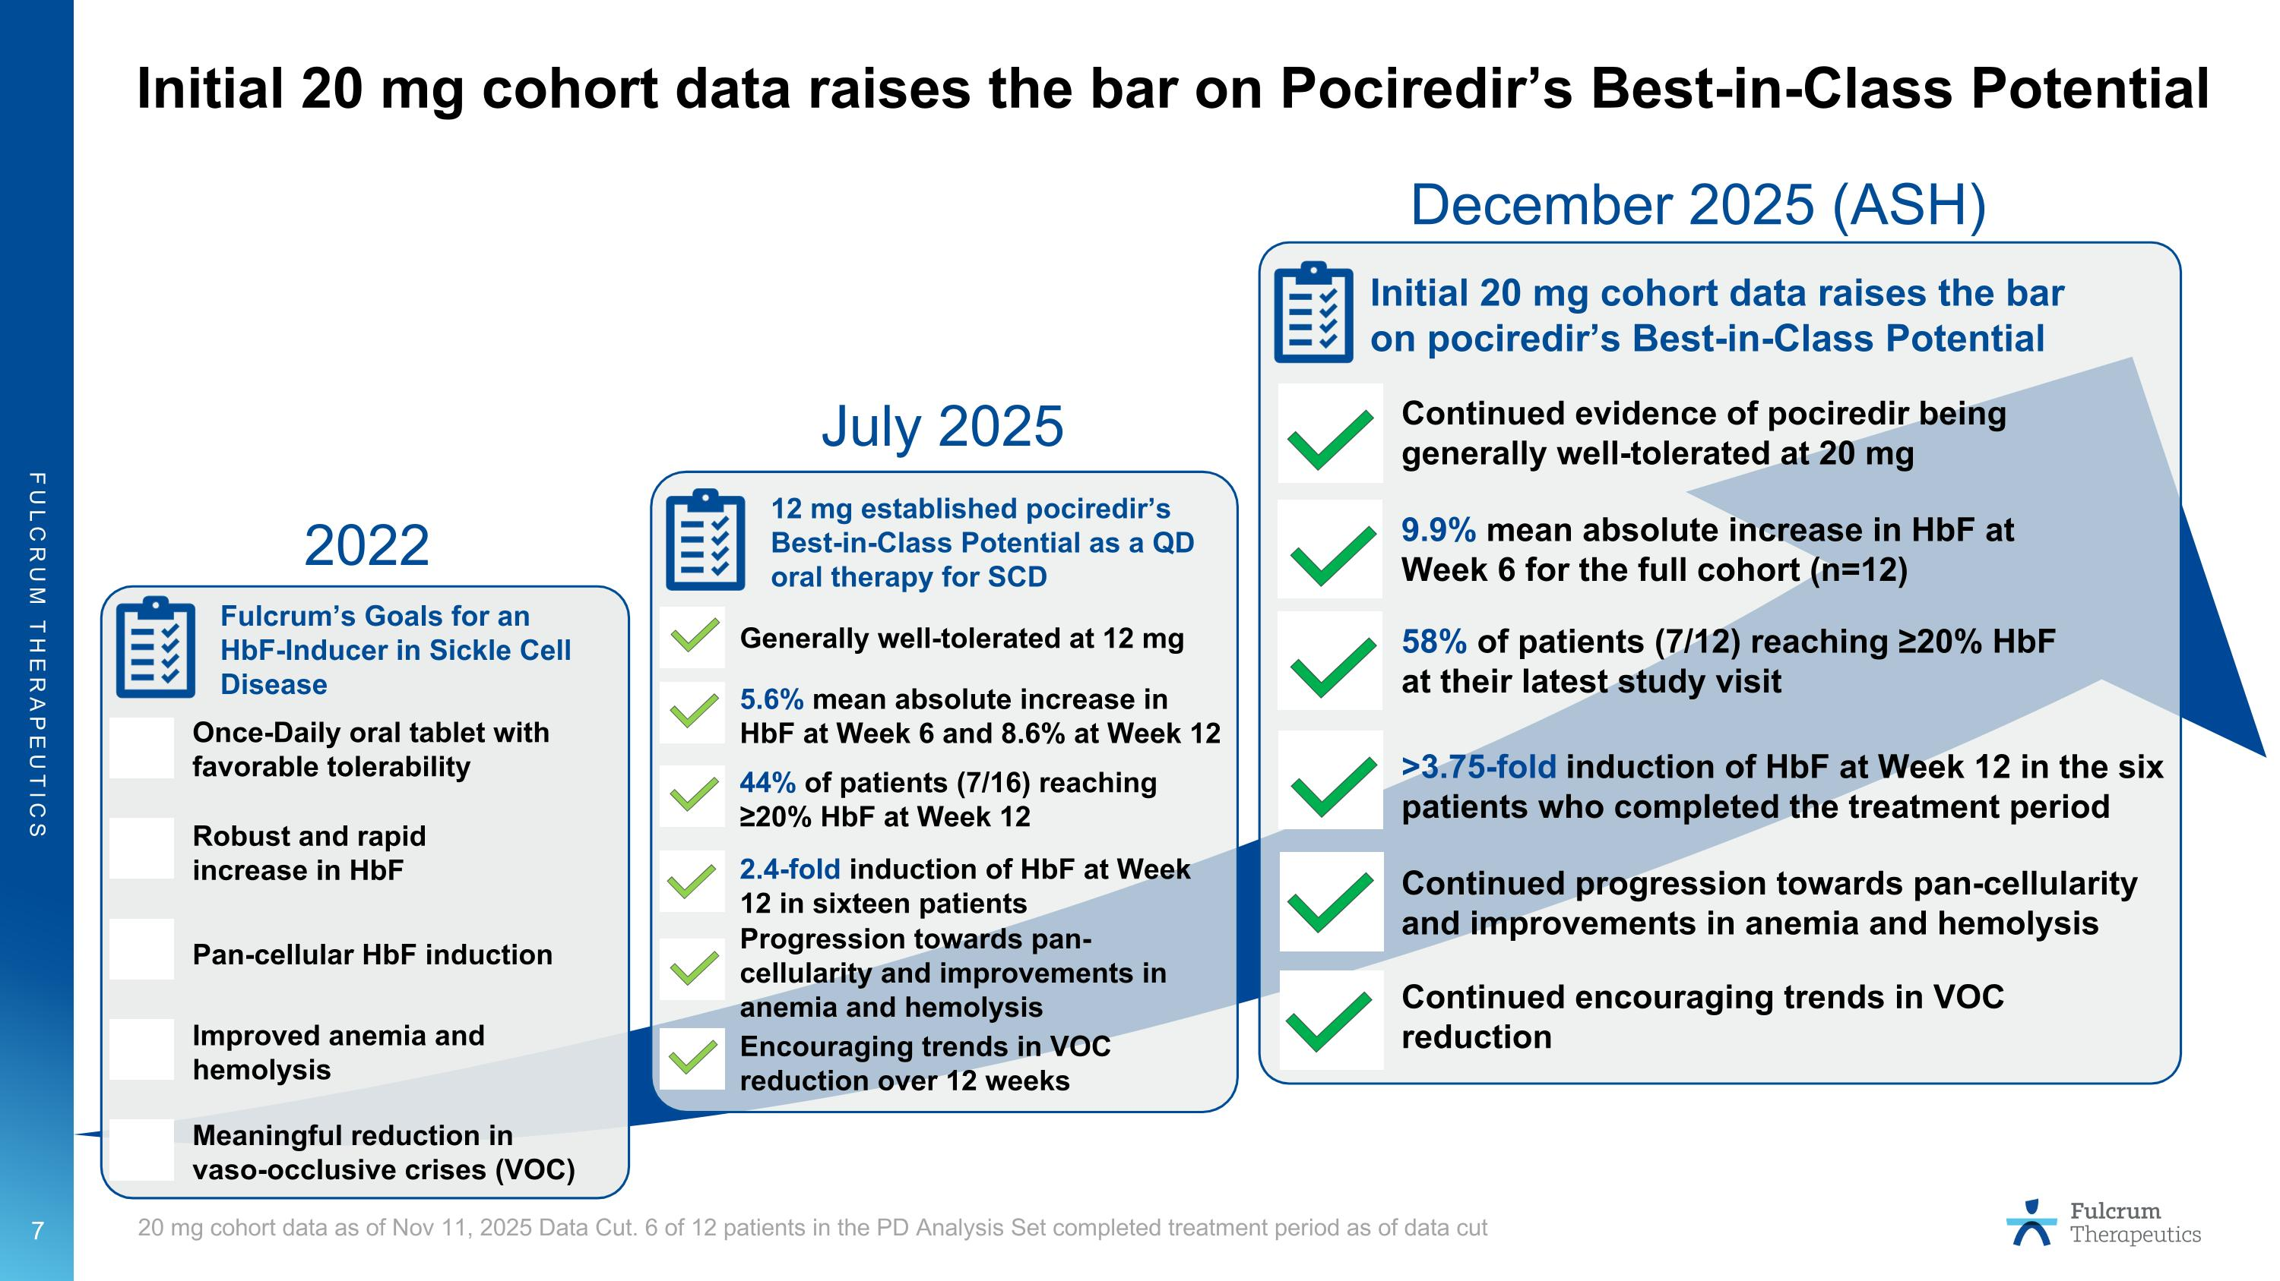
Initial 20 mg cohort data raises the bar on Pociredir’s Best-in-Class Potential 20 mg cohort data as of Nov 11, 2025 Data Cut. 6 of 12 patients in the PD Analysis Set completed treatment period as of data cut Pan-cellular HbF induction Robust and rapid increase in HbF Improved anemia and hemolysis Meaningful reduction in vaso-occlusive crises (VOC) Once-Daily oral tablet with favorable tolerability Fulcrum’s Goals for an HbF-Inducer in Sickle Cell Disease 2.4-fold induction of HbF at Week 12 in sixteen patients 5.6% mean absolute increase in HbF at Week 6 and 8.6% at Week 12 Progression towards pan-cellularity and improvements in anemia and hemolysis Encouraging trends in VOC reduction over 12 weeks Generally well-tolerated at 12 mg 12 mg established pociredir’s Best-in-Class Potential as a QD oral therapy for SCD 9.9% mean absolute increase in HbF at Week 6 for the full cohort (n=12) Continued evidence of pociredir being generally well-tolerated at 20 mg Initial 20 mg cohort data raises the bar on pociredir’s Best-in-Class Potential Continued progression towards pan-cellularity and improvements in anemia and hemolysis Continued encouraging trends in VOC reduction >3.75-fold induction of HbF at Week 12 in the six patients who completed the treatment period 58% of patients (7/12) reaching ≥20% HbF at their latest study visit 44% of patients (7/16) reaching ≥20% HbF at Week 12 2022 July 2025 December 2025 (ASH)

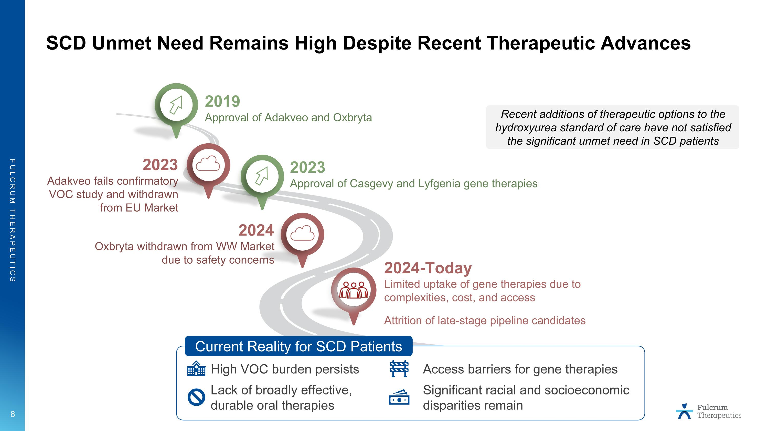
SCD Unmet Need Remains High Despite Recent Therapeutic Advances 2019 Approval of Adakveo and Oxbryta 2024 Oxbryta withdrawn from WW Market?due to safety concerns 2023 Approval of Casgevy and Lyfgenia gene therapies 2024-Today Limited uptake of gene therapies due to complexities, cost, and access Attrition of late-stage pipeline candidates Current Reality for SCD Patients High VOC burden persists Access barriers for gene therapies Lack of broadly effective, ?durable oral therapies Significant racial and socioeconomic ?disparities remain 2023 Adakveo fails confirmatory VOC study and withdrawn from EU Market Recent additions of therapeutic options to the hydroxyurea standard of care have not satisfied the significant unmet need in SCD patients

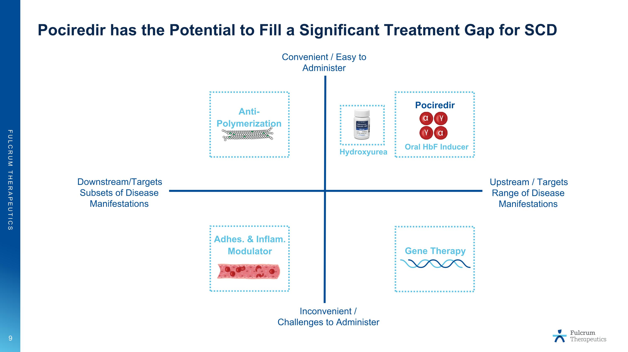
Pociredir has the Potential to Fill a Significant Treatment Gap for SCD Anti-Polymerization Adhes. & Inflam. Modulator Gene Therapy Upstream / Targets Range of Disease Manifestations Downstream/Targets Subsets of Disease Manifestations Convenient / Easy to Administer Inconvenient / Challenges to Administer Pociredir α α γ γ Oral HbF Inducer Hydroxyurea

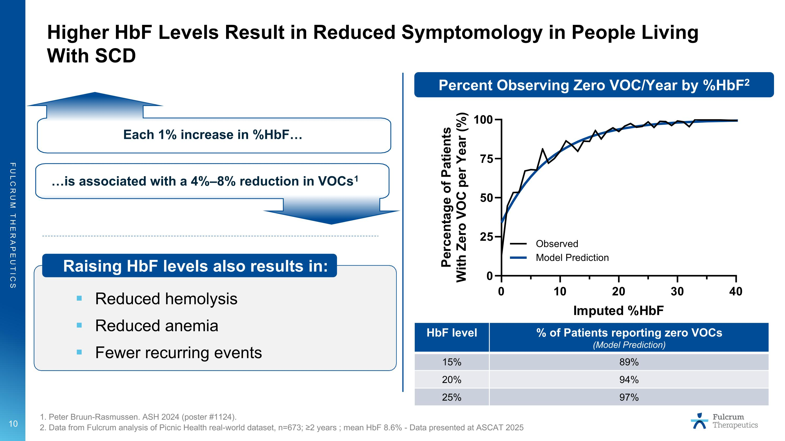
Higher HbF Levels Result in Reduced Symptomology in People Living With SCD Reduced hemolysis Reduced anemia Fewer recurring events 1. Peter Bruun-Rasmussen. ASH 2024 (poster #1124). 2. Data from Fulcrum analysis of Picnic Health real-world dataset, n=673; ≥2 years ; mean HbF 8.6% - Data presented at ASCAT 2025 Percent Observing Zero VOC/Year by %HbF2 Each 1% increase in %HbF is associated with a 4%–8% reduction in VOCs1 Raising HbF levels also results in: HbF level % of Patients reporting zero VOCs (Model Prediction) 15% 89% 20% 94% 25% 97%

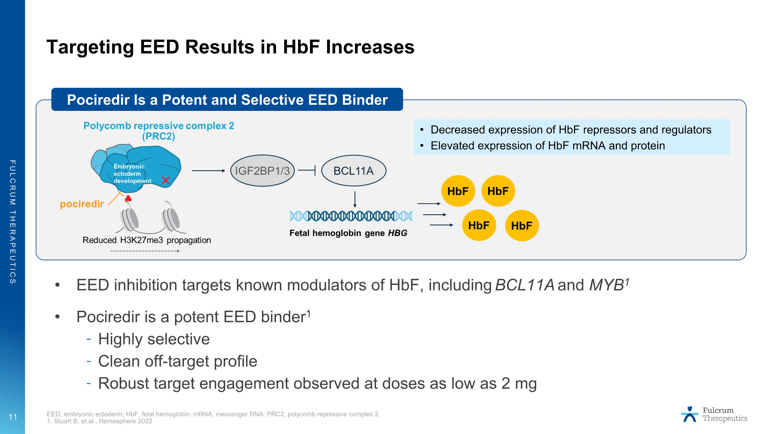
Targeting EED Results in HbF Increases EED inhibition targets known modulators of HbF, including BCL11A and MYB1 Pociredir is a potent EED binder1 Highly selective Clean off-target profile Robust target engagement observed at doses as low as 2 mg Pociredir Is a Potent and Selective EED Binder Decreased expression of HbF repressors and regulators Elevated expression of HbF mRNA and protein EED, embryonic ectoderm; HbF, fetal hemoglobin; mRNA, messenger RNA; PRC2, polycomb repressive complex 2. 1. Stuart B, et.al., Hemasphere 2022

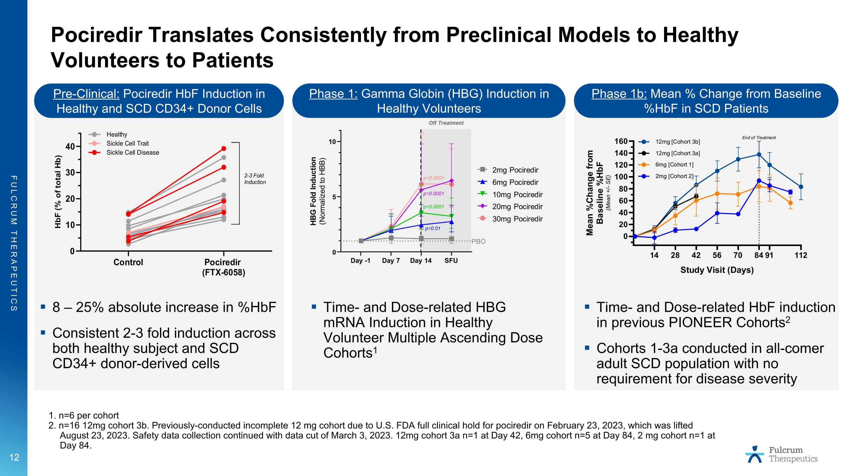
Pociredir Translates Consistently from Preclinical Models to Healthy Volunteers to Patients 12 1. n=6 per cohort 2. n=16 12mg cohort 3b. Previously-conducted incomplete 12 mg cohort due to U.S. FDA full clinical hold for pociredir on February 23, 2023, which was lifted August 23, 2023. Safety data collection continued with data cut of March 3, 2023. 12mg cohort 3a n=1 at Day 42, 6mg cohort n=5 at Day 84, 2 mg cohort n=1 at Day 84. Pre-Clinical: Pociredir HbF Induction in Healthy and SCD CD34+ Donor Cells Phase 1: Gamma Globin (HBG) Induction in Healthy Volunteers Phase 1b: Mean % Change from Baseline %HbF in SCD Patients 8 – 25% absolute increase in %HbF Consistent 2-3 fold induction across both healthy subject and SCD CD34+ donor-derived cells Time- and Dose-related HBG mRNA Induction in Healthy Volunteer Multiple Ascending Dose Cohorts1 Time- and Dose-related HbF induction in previous PIONEER Cohorts2 Cohorts 1-3a conducted in all-comer adult SCD population with no requirement for disease severity

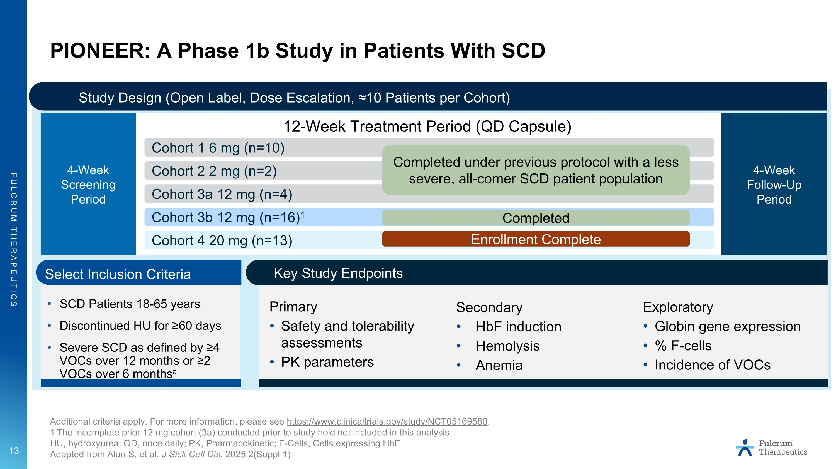
PIONEER: A Phase 1b Study in Patients With SCD Additional criteria apply. For more information, please see https://www.clinicaltrials.gov/study/NCT05169580. 1 The incomplete prior 12 mg cohort (3a) conducted prior to study hold not included in this analysis HU, hydroxyurea; QD, once daily; PK, Pharmacokinetic; F-Cells, Cells expressing HbF Adapted from Alan S, et al. J Sick Cell Dis. 2025;2(Suppl 1) Study Design (Open Label, Dose Escalation, ≈10 Patients per Cohort) 12-Week Treatment Period (QD Capsule) 4-Week Screening Period 4-Week Follow-Up Period Cohort 1 6 mg (n=10) Cohort 2 2 mg (n=2) Cohort 3b 12 mg (n=16)1 Cohort 4 20 mg (n=13) Enrollment Complete Completed Cohort 3a 12 mg (n=4) Completed under previous protocol with a less severe, all-comer SCD patient population Key Study Endpoints SCD Patients 18-65 years Discontinued HU for ≥60 days Severe SCD as defined by ≥4 VOCs over 12 months or ≥2 VOCs over 6 monthsa Select Inclusion Criteria Secondary HbF induction Hemolysis Anemia Primary Safety and tolerability assessments PK parameters Exploratory Globin gene expression % F-cells Incidence of VOCs

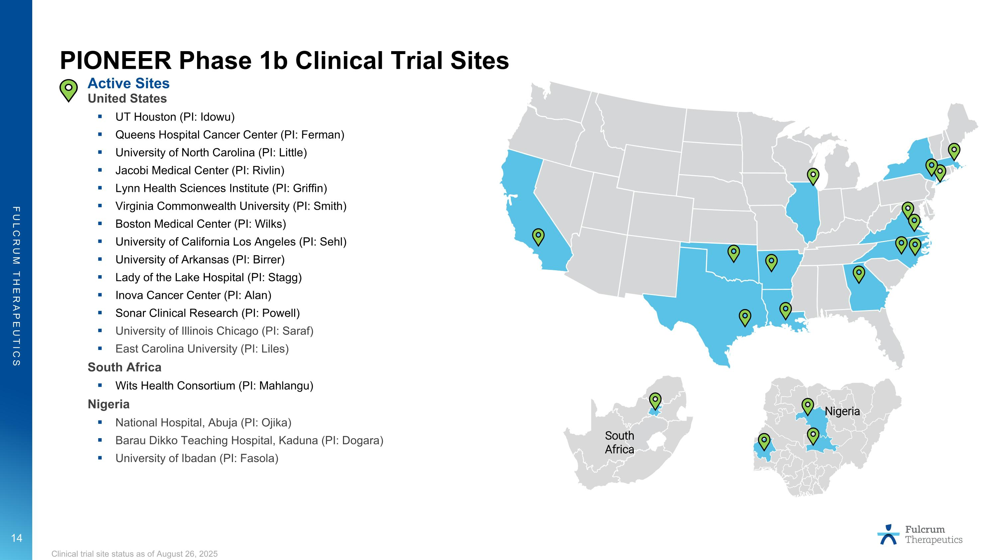
Active Sites United States UT Houston (PI: Idowu) Queens Hospital Cancer Center (PI: Ferman) University of North Carolina (PI: Little) Jacobi Medical Center (PI: Rivlin) Lynn Health Sciences Institute (PI: Griffin) Virginia Commonwealth University (PI: Smith) Boston Medical Center (PI: Wilks) University of California Los Angeles (PI: Sehl) University of Arkansas (PI: Birrer) Lady of the Lake Hospital (PI: Stagg) Inova Cancer Center (PI: Alan) Sonar Clinical Research (PI: Powell) University of Illinois Chicago (PI: Saraf) East Carolina University (PI: Liles) South Africa Wits Health Consortium (PI: Mahlangu) Nigeria National Hospital, Abuja (PI: Ojika) Barau Dikko Teaching Hospital, Kaduna (PI: Dogara) University of Ibadan (PI: Fasola) South Africa Nigeria Clinical trial site status as of August 26, 2025 PIONEER Phase 1b Clinical Trial Sites

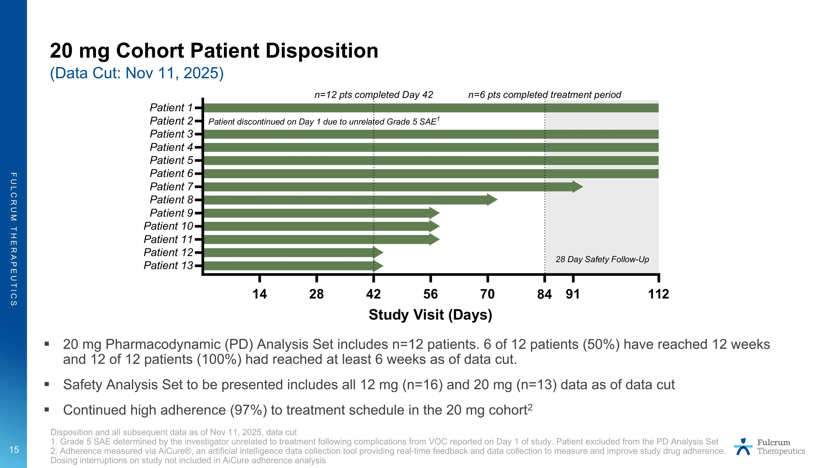
20 mg Cohort Patient Disposition (Data Cut: Nov 11, 2025) Disposition and all subsequent data as of Nov 11, 2025, data cut 1. Grade 5 SAE determined by the investigator unrelated to treatment following complications from VOC reported on Day 1 of study. Patient excluded from the PD Analysis Set 2. Adherence measured via AiCure®, an artificial intelligence data collection tool providing real-time feedback and data collection to measure and improve study drug adherence. Dosing interruptions on study not included in AiCure adherence analysis 20 mg Pharmacodynamic (PD) Analysis Set includes n=12 patients. 6 of 12 patients (50%) have reached 12 weeks and 12 of 12 patients (100%) had reached at least 6 weeks as of data cut. Safety Analysis Set to be presented includes all 12 mg (n=16) and 20 mg (n=13) data as of data cut Continued high adherence (97%) to treatment schedule in the 20 mg cohort2

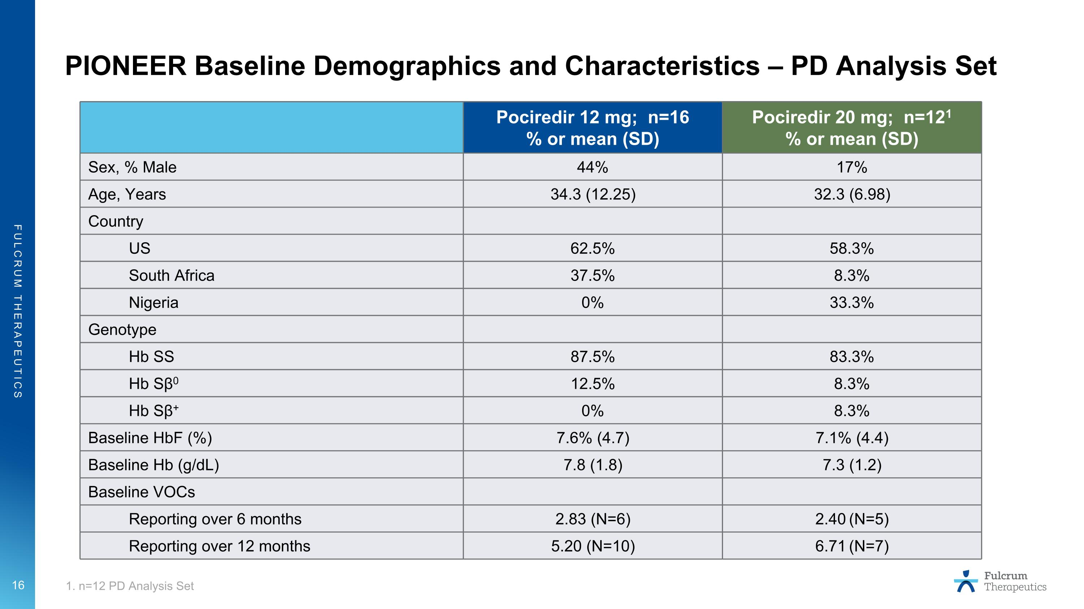
PIONEER Baseline Demographics and Characteristics – PD Analysis Set 1. n=12 PD Analysis Set Pociredir 12 mg; n=16 % or mean (SD) Pociredir 20 mg; n=121 % or mean (SD) Sex, % Male 44% 17% Age, Years 34.3 (12.25) 32.3 (6.98) Country US 62.5% 58.3% South Africa 37.5% 8.3% Nigeria 0% 33.3% Genotype Hb SS 87.5% 83.3% Hb Sβ0 12.5% 8.3% Hb Sβ+ 0% 8.3% Baseline HbF (%) 7.6% (4.7) 7.1% (4.4) Baseline Hb (g/dL) 7.8 (1.8) 7.3 (1.2) Baseline VOCs Reporting over 6 months 2.83 (N=6) 2.40 (N=5) Reporting over 12 months 5.20 (N=10) 6.71 (N=7)

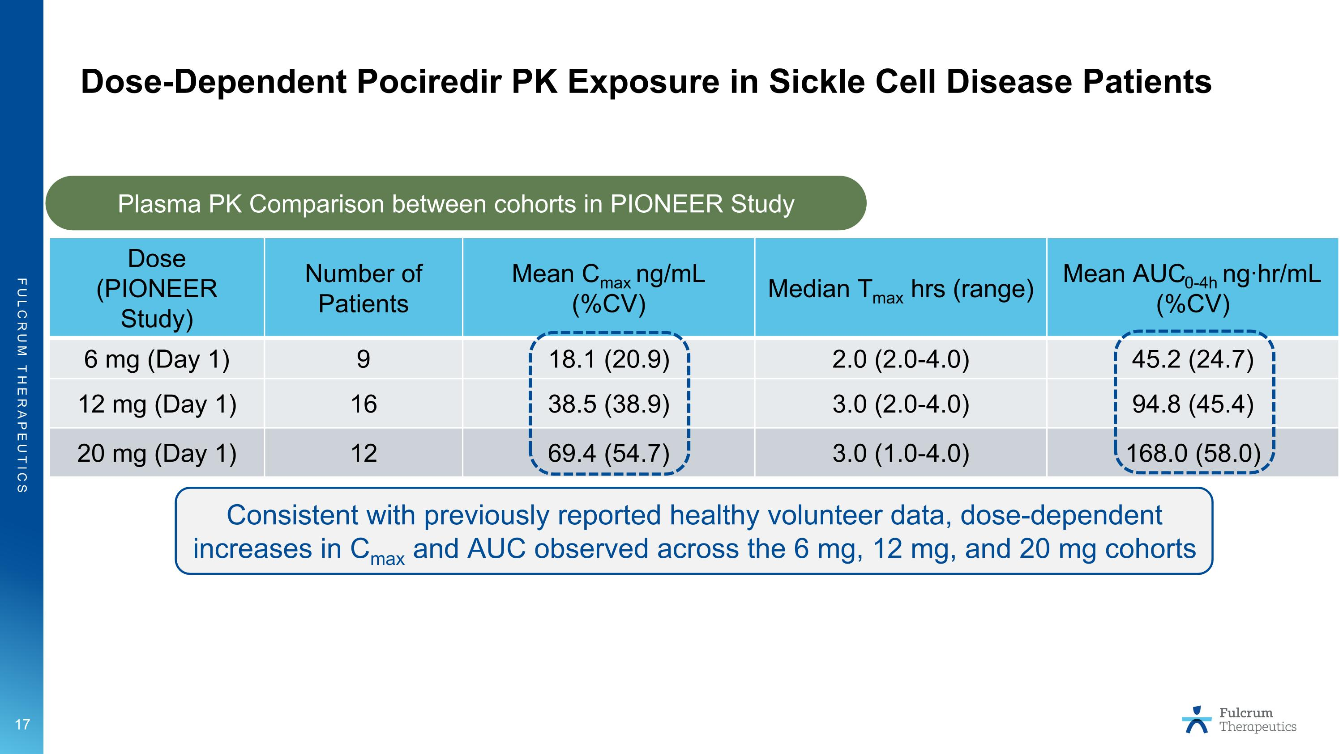
Dose-Dependent Pociredir PK Exposure in Sickle Cell Disease Patients Dose (PIONEER Study) Number of Patients Mean Cmax ng/mL (%CV) Median Tmax hrs (range) Mean AUC0-4h ng·hr/mL (%CV) 6 mg (Day 1) 9 18.1 (20.9) 2.0 (2.0-4.0) 45.2 (24.7) 12 mg (Day 1) 16 38.5 (38.9) 3.0 (2.0-4.0) 94.8 (45.4) 20 mg (Day 1) 12 69.4 (54.7) 3.0 (1.0-4.0) 168.0 (58.0) Plasma PK Comparison between cohorts in PIONEER Study Consistent with previously reported healthy volunteer data, dose-dependent increases in Cmax and AUC observed across the 6 mg, 12 mg, and 20 mg cohorts

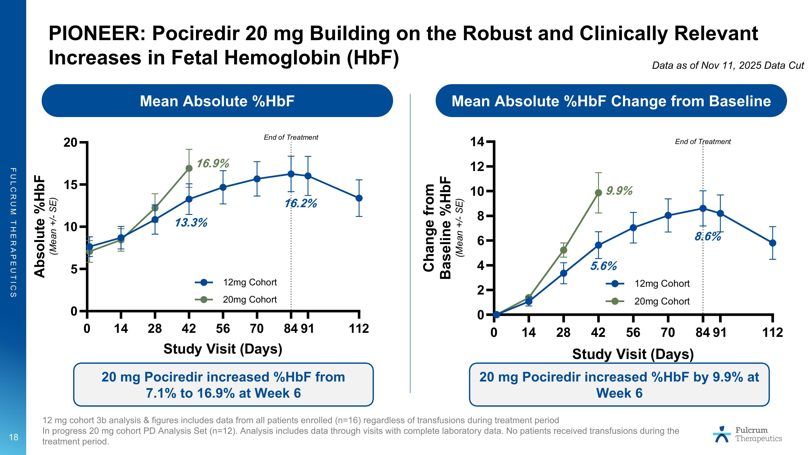
PIONEER: Pociredir 20 mg Building on the Robust and Clinically Relevant Increases in Fetal Hemoglobin (HbF) Mean Absolute %HbF Mean Absolute %HbF Change from Baseline 12 mg cohort 3b analysis & figures includes data from all patients enrolled (n=16) regardless of transfusions during treatment period In progress 20 mg cohort PD Analysis Set (n=12). Analysis includes data through visits with complete laboratory data. No patients received transfusions during the treatment period. 20 mg Pociredir increased %HbF from 7.1% to 16.9% at Week 6 20 mg Pociredir increased %HbF by 9.9% at Week 6 8.6% 9.9% 16.2% 16.9% 5.6% 13.3% Data as of Nov 11, 2025 Data Cut

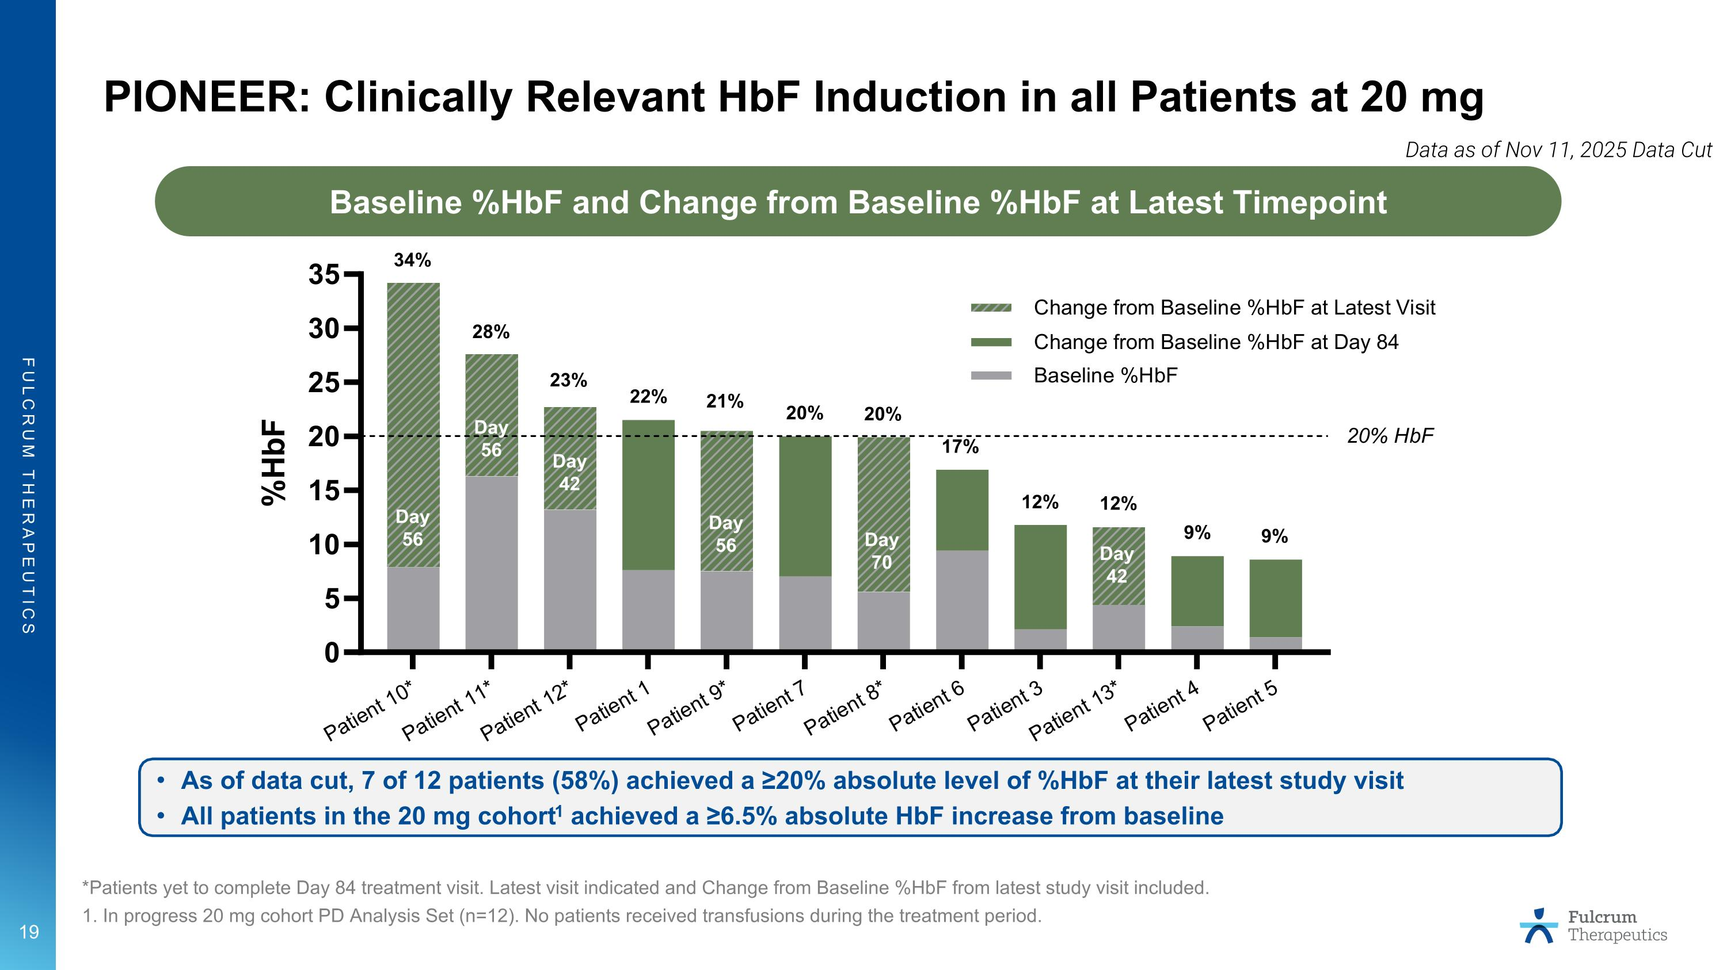
PIONEER: Clinically Relevant HbF Induction in all Patients at 20 mg *Patients yet to complete Day 84 treatment visit. Latest visit indicated and Change from Baseline %HbF from latest study visit included. 1. In progress 20 mg cohort PD Analysis Set (n=12). No patients received transfusions during the treatment period. Baseline %HbF and Change from Baseline %HbF at Latest Timepoint 34% 28% 23% 22% 21% 20% 20% 17% 12% 9% 9% 12% As of data cut, 7 of 12 patients (58%) achieved a ≥20% absolute level of %HbF at their latest study visit All patients in the 20 mg cohort1 achieved a ≥6.5% absolute HbF increase from baseline Day 56 Day 56 Day 56 Day 42 Day 70 Day 42 Data as of Nov 11, 2025 Data Cut

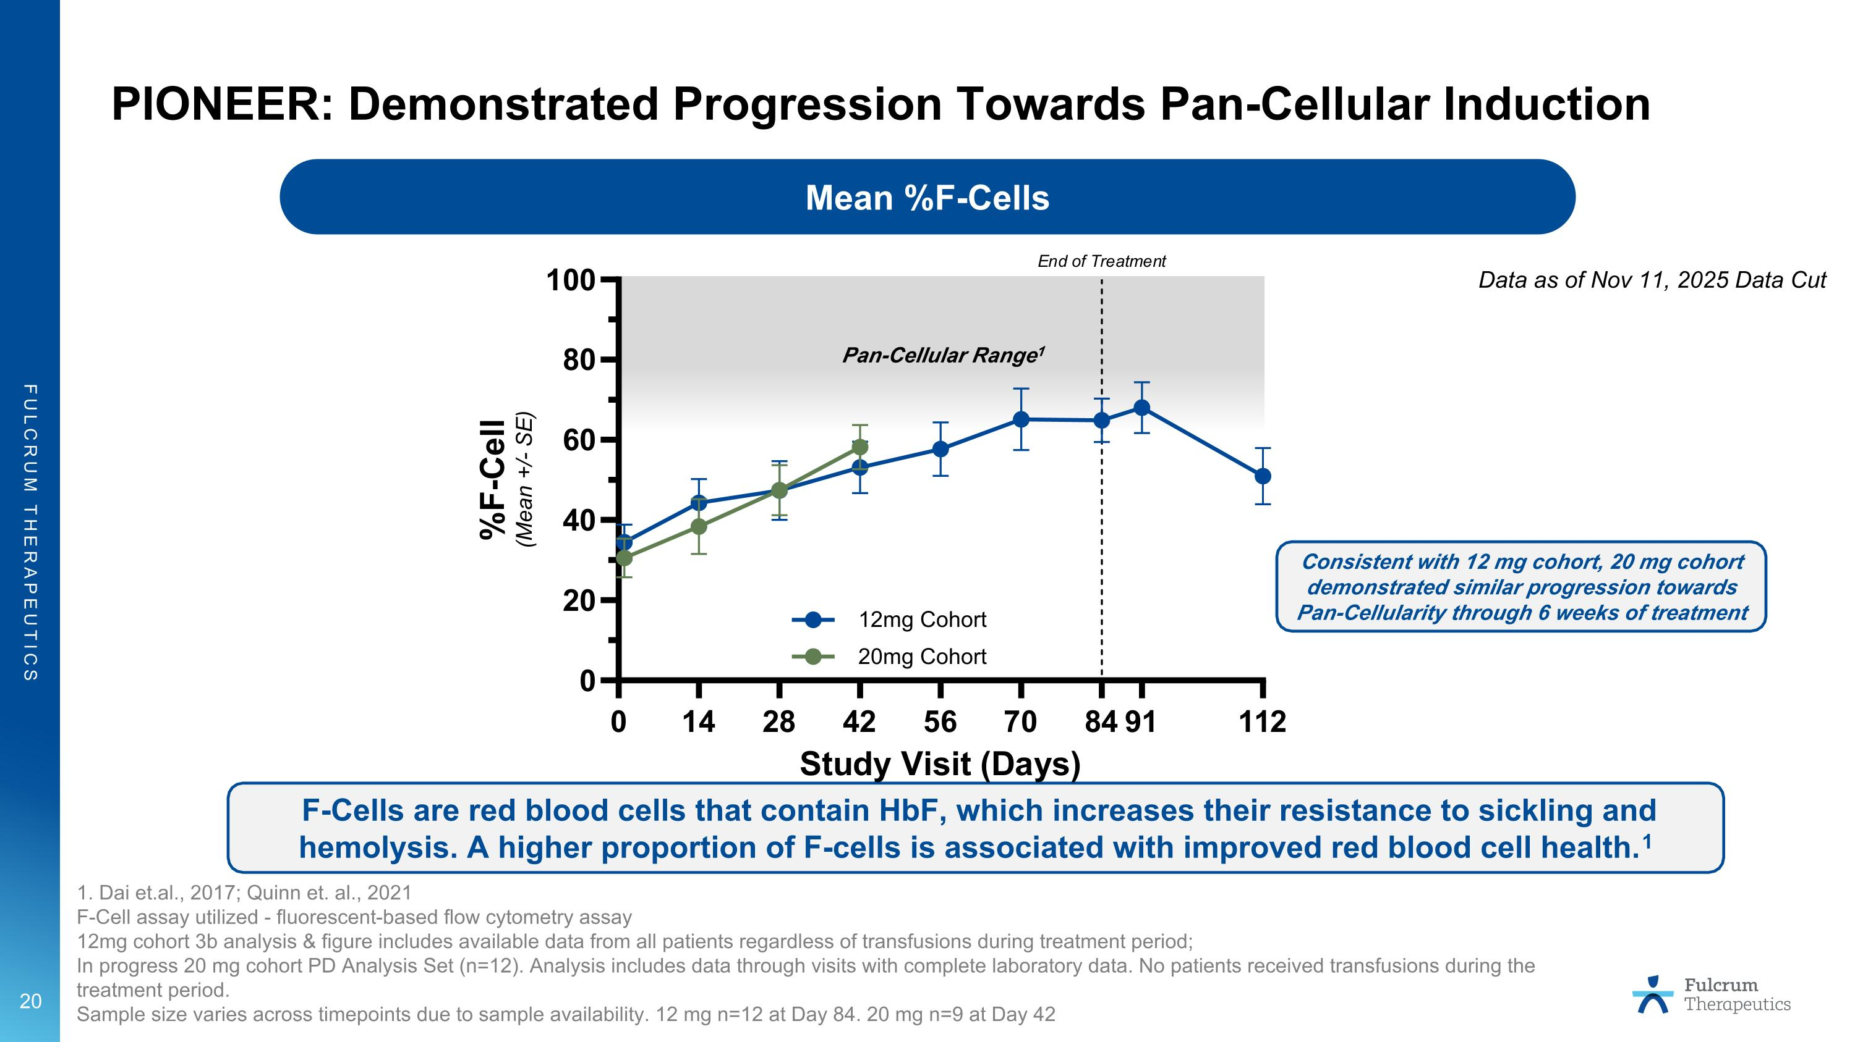
PIONEER: Demonstrated Progression Towards Pan-Cellular Induction 1. Dai et.al., 2017; Quinn et. al., 2021 F-Cell assay utilized - fluorescent-based flow cytometry assay 12mg cohort 3b analysis & figure includes available data from all patients regardless of transfusions during treatment period; In progress 20 mg cohort PD Analysis Set (n=12). Analysis includes data through visits with complete laboratory data. No patients received transfusions during the treatment period. Sample size varies across timepoints due to sample availability. 12 mg n=12 at Day 84. 20 mg n=9 at Day 42 Mean %F-Cells F-Cells are red blood cells that contain HbF, which increases their resistance to sickling and hemolysis. A higher proportion of F-cells is associated with improved red blood cell health.1 Pan-Cellular Range1 Consistent with 12 mg cohort, 20 mg cohort demonstrated similar progression towards Pan-Cellularity through 6 weeks of treatment Data as of Nov 11, 2025 Data Cut

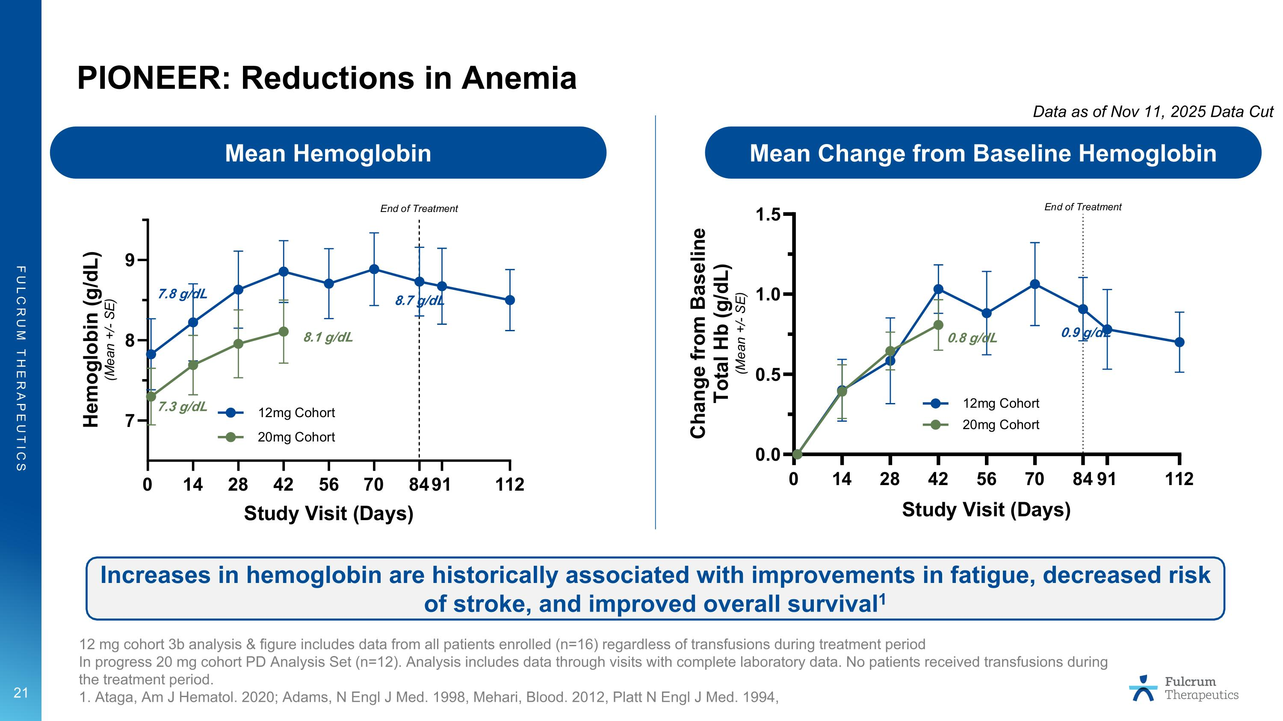
PIONEER: Reductions in Anemia Mean Hemoglobin Mean Change from Baseline Hemoglobin Increases in hemoglobin are historically associated with improvements in fatigue, decreased risk of stroke, and improved overall survival1 12 mg cohort 3b analysis & figure includes data from all patients enrolled (n=16) regardless of transfusions during treatment period In progress 20 mg cohort PD Analysis Set (n=12). Analysis includes data through visits with complete laboratory data. No patients received transfusions during the treatment period. 1. Ataga, Am J Hematol. 2020; Adams, N Engl J Med. 1998, Mehari, Blood. 2012, Platt N Engl J Med. 1994, 7.8 g/dL 7.3 g/dL 8.7 g/dL 8.1 g/dL 0.9 g/dL 0.8 g/dL Data as of Nov 11, 2025 Data Cut

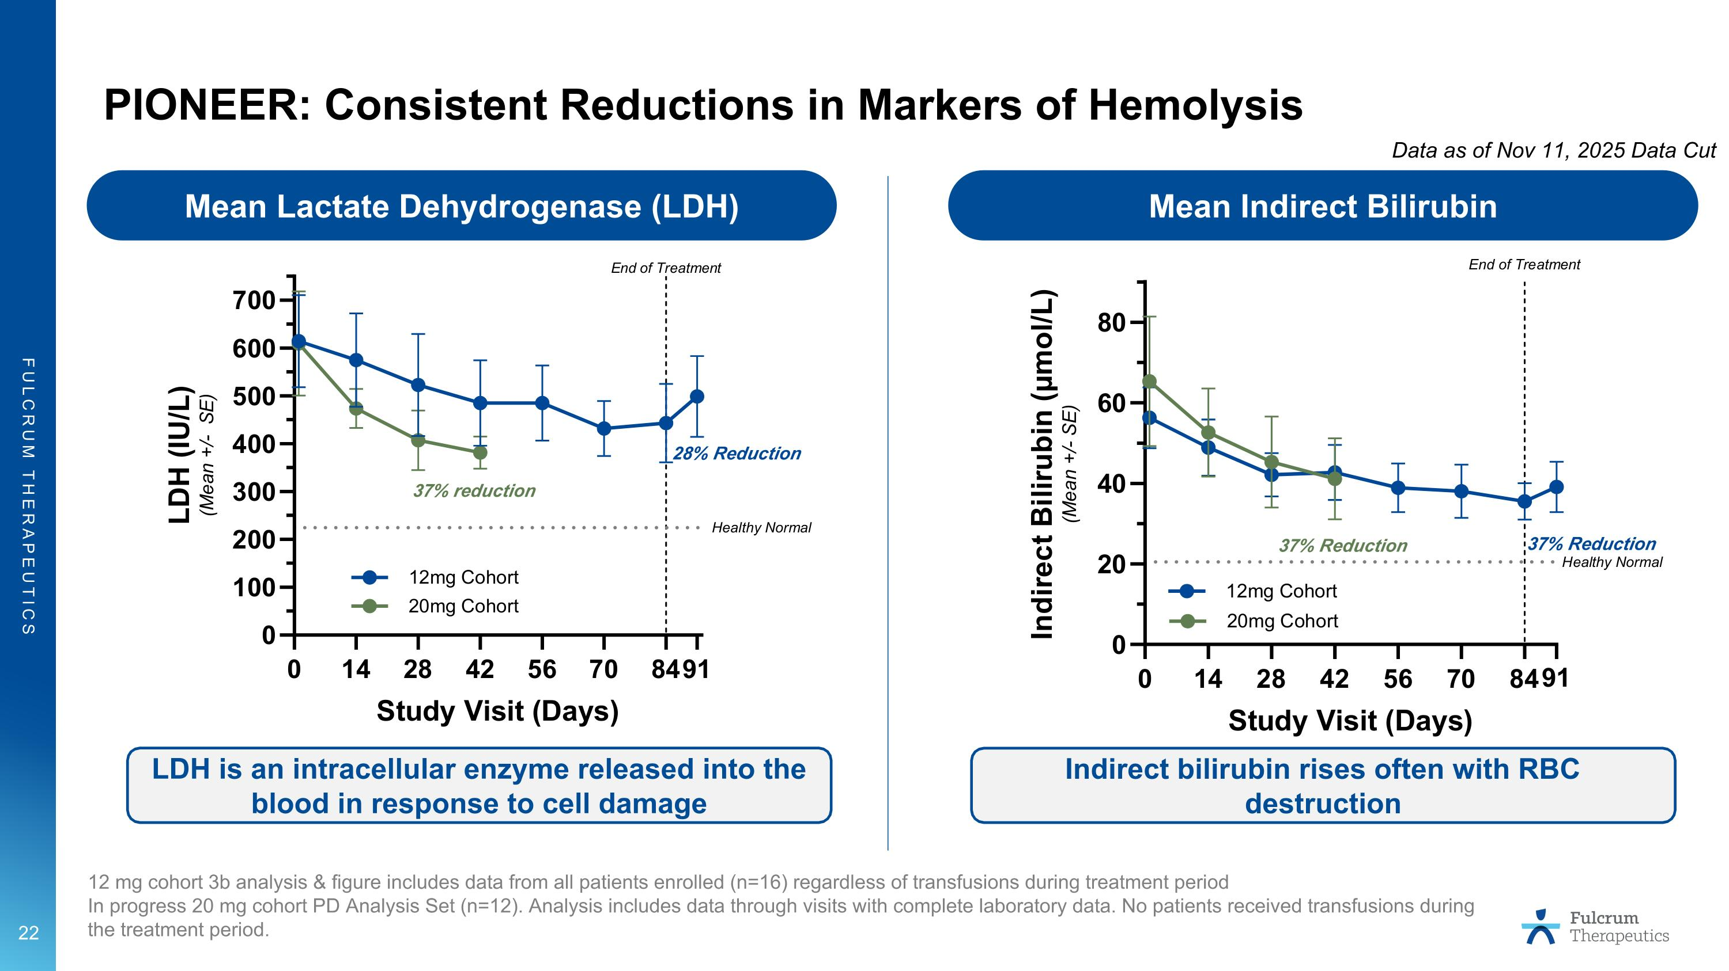
PIONEER: Consistent Reductions in Markers of Hemolysis Mean Indirect Bilirubin Mean Lactate Dehydrogenase (LDH) LDH is an intracellular enzyme released into the blood in response to cell damage Indirect bilirubin rises often with RBC destruction 12 mg cohort 3b analysis & figure includes data from all patients enrolled (n=16) regardless of transfusions during treatment period In progress 20 mg cohort PD Analysis Set (n=12). Analysis includes data through visits with complete laboratory data. No patients received transfusions during the treatment period. 28% Reduction 37% reduction 37% Reduction 37% Reduction Data as of Nov 11, 2025 Data Cut

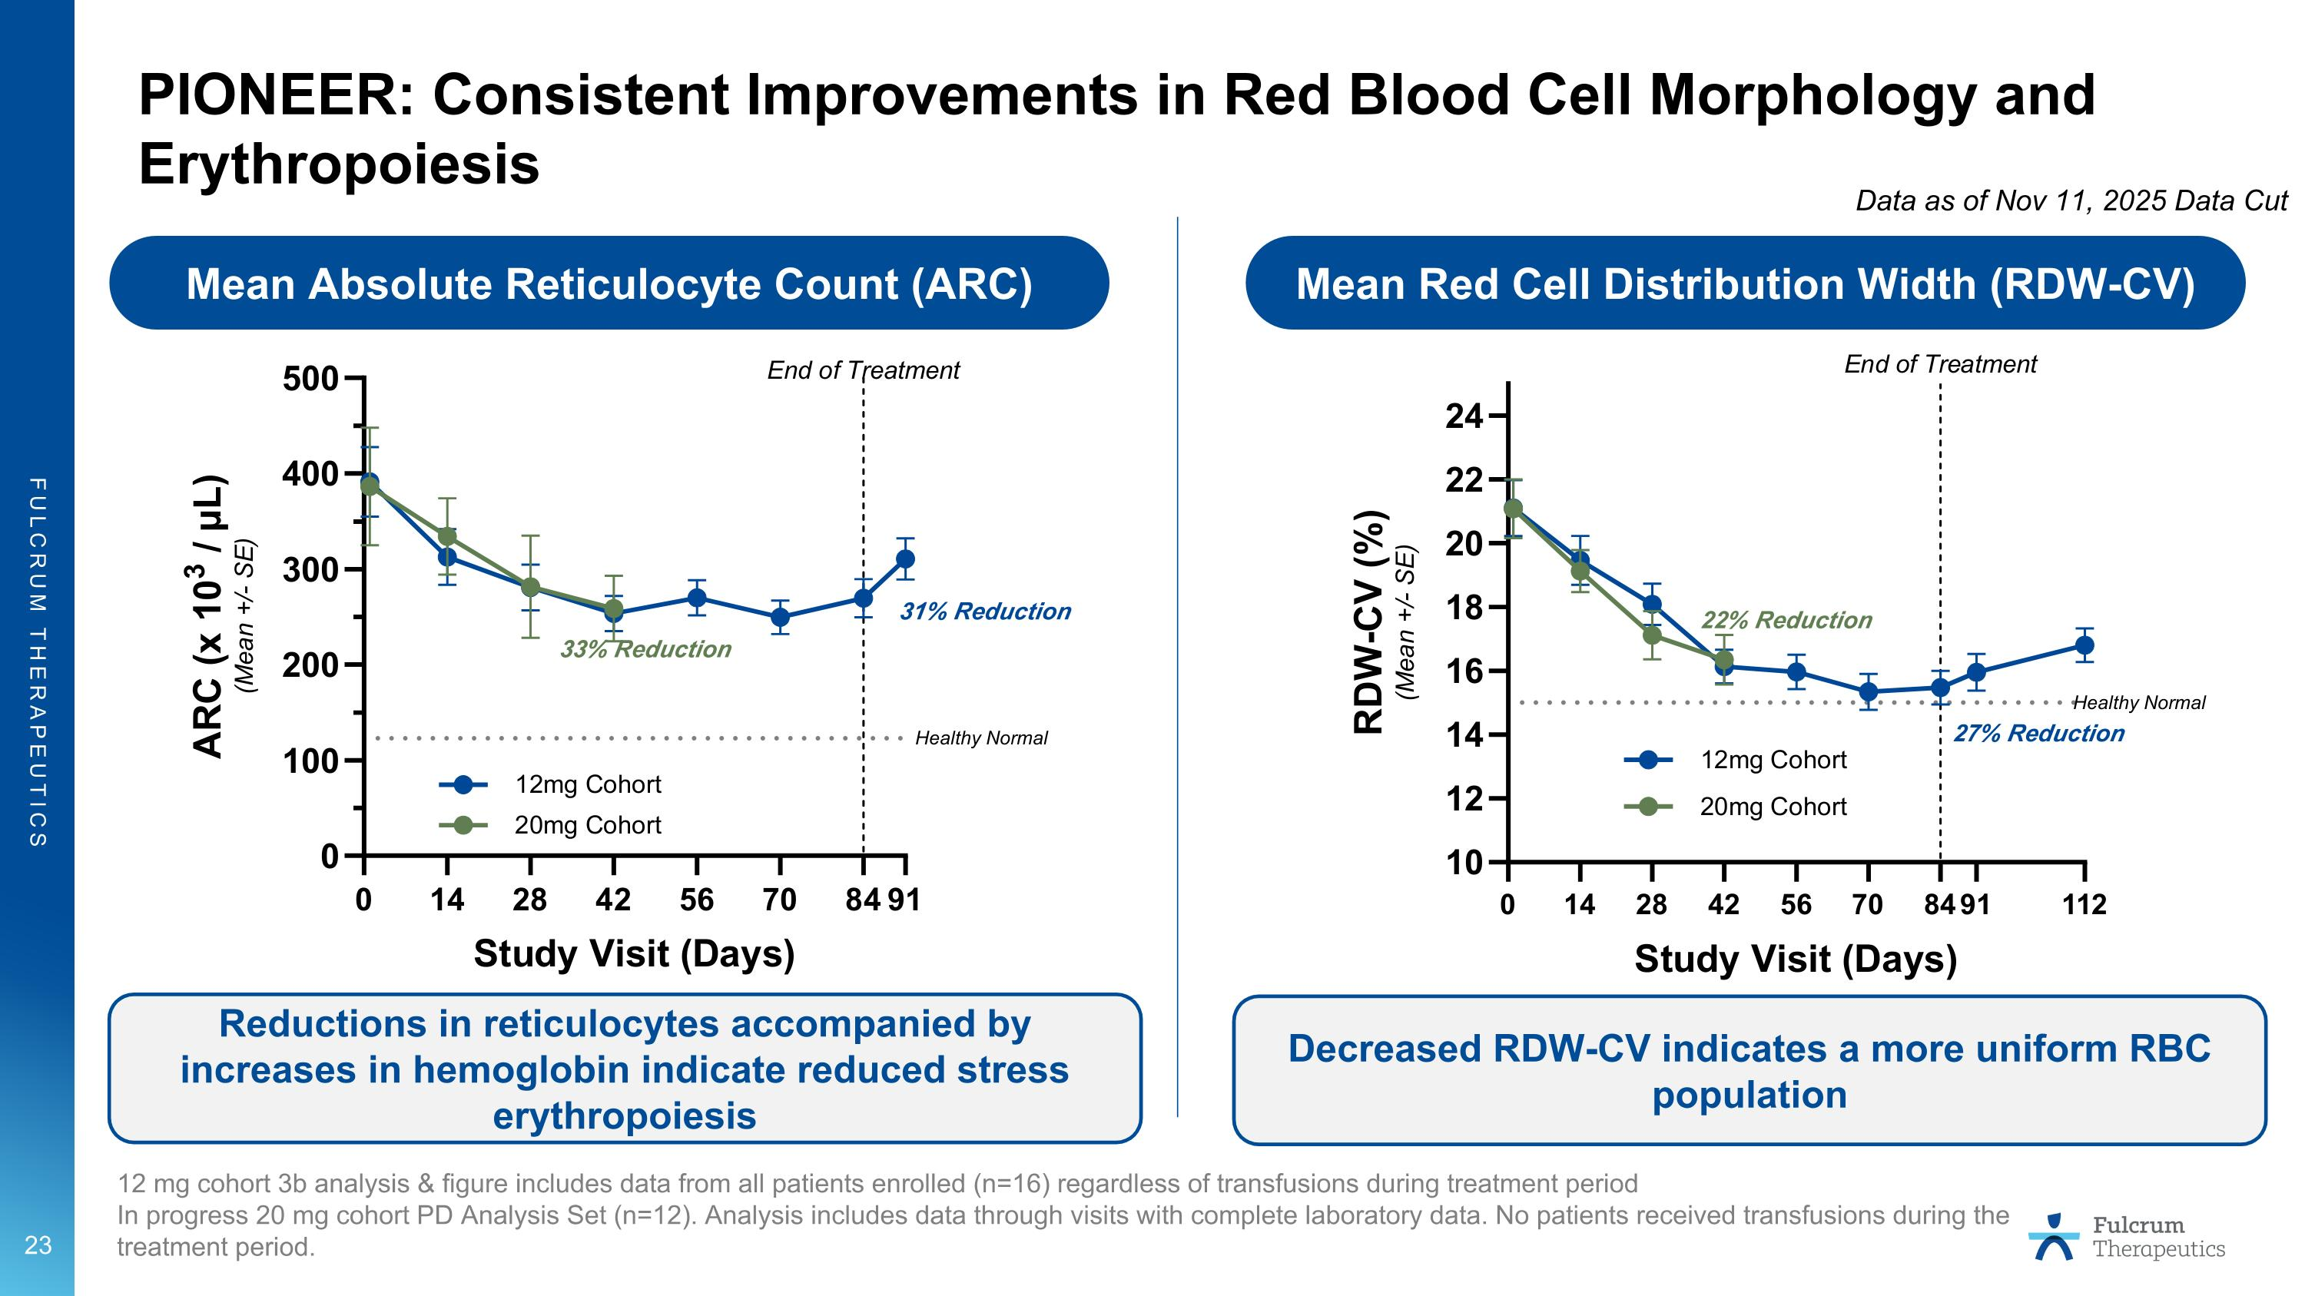
PIONEER: Consistent Improvements in Red Blood Cell Morphology and Erythropoiesis Mean Absolute Reticulocyte Count (ARC) Mean Red Cell Distribution Width (RDW-CV) Reductions in reticulocytes accompanied by increases in hemoglobin indicate reduced stress erythropoiesis Decreased RDW-CV indicates a more uniform RBC population 12 mg cohort 3b analysis & figure includes data from all patients enrolled (n=16) regardless of transfusions during treatment period In progress 20 mg cohort PD Analysis Set (n=12). Analysis includes data through visits with complete laboratory data. No patients received transfusions during the treatment period. 31% Reduction 33% Reduction 27% Reduction 22% Reduction Data as of Nov 11, 2025 Data Cut

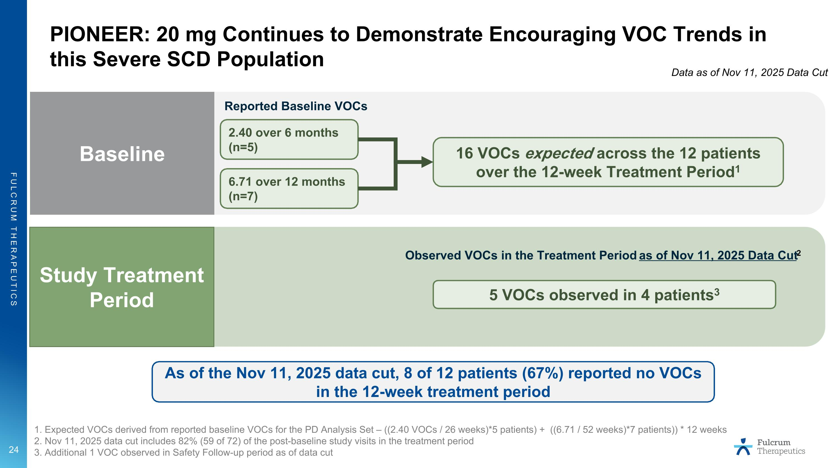
PIONEER: 20 mg Continues to Demonstrate Encouraging VOC Trends in this Severe SCD Population 1. Expected VOCs derived from reported baseline VOCs for the PD Analysis Set – ((2.40 VOCs / 26 weeks)*5 patients) + ((6.71 / 52 weeks)*7 patients)) * 12 weeks 2. Nov 11, 2025 data cut includes 82% (59 of 72) of the post-baseline study visits in the treatment period 3. Additional 1 VOC observed in Safety Follow-up period as of data cut As of the Nov 11, 2025 data cut, 8 of 12 patients (67%) reported no VOCs in the 12-week treatment period Reported Baseline VOCs 2.40 over 6 months (n=5) 6.71 over 12 months (n=7) 16 VOCs expected across the 12 patients over the 12-week Treatment Period1 Study Treatment Period Baseline 5 VOCs observed in 4 patients3 Observed VOCs in the Treatment Period as of Nov 11, 2025 Data Cut2 Data as of Nov 11, 2025 Data Cut

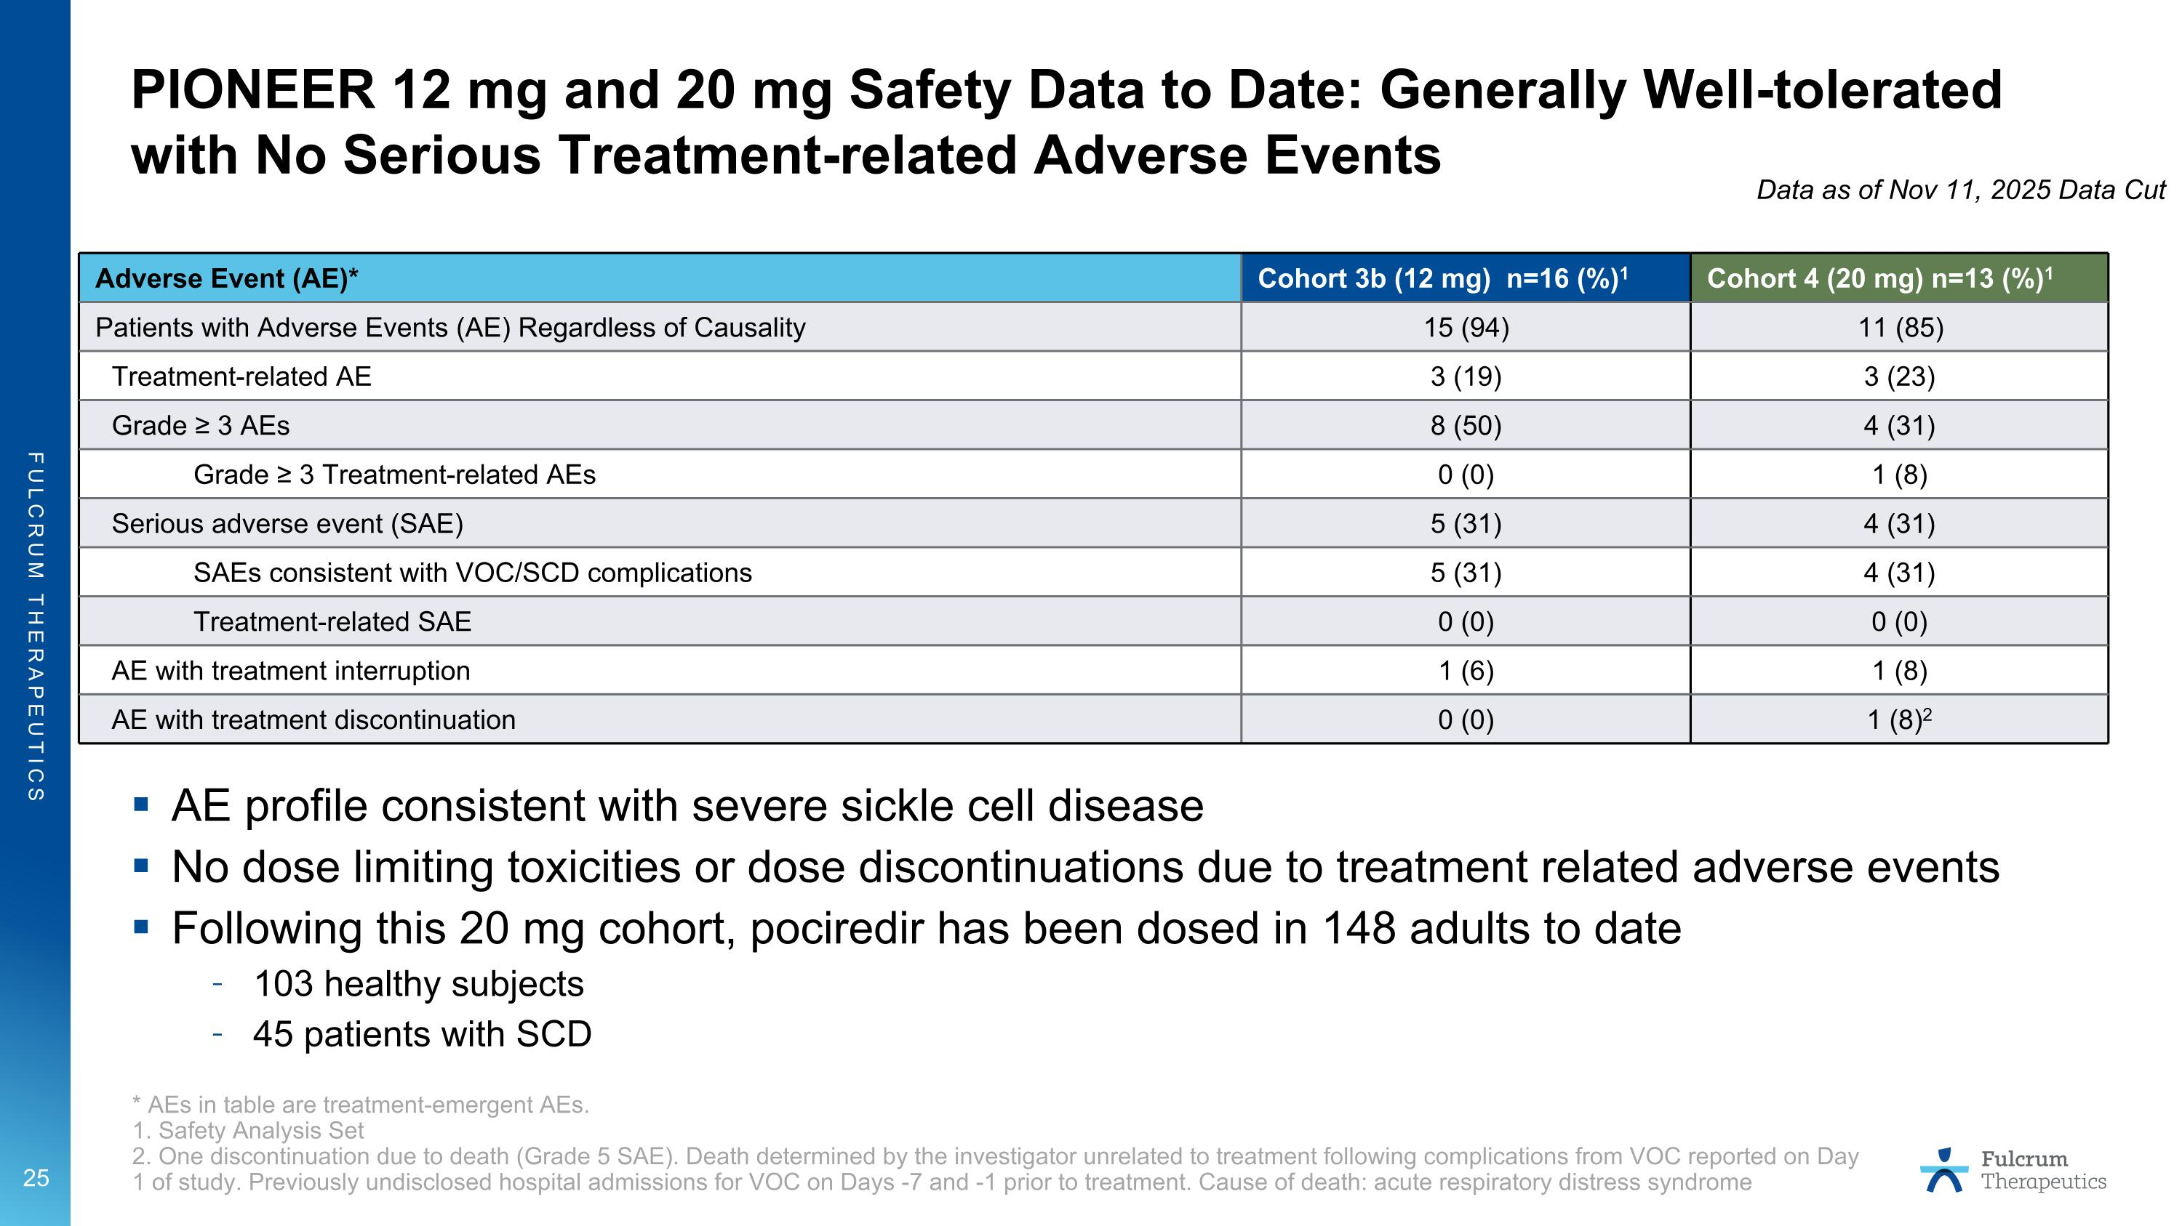
PIONEER 12 mg and 20 mg Safety Data to Date: Generally Well-tolerated with No Serious Treatment-related Adverse Events * AEs in table are treatment-emergent AEs. 1. Safety Analysis Set 2. One discontinuation due to death (Grade 5 SAE). Death determined by the investigator unrelated to treatment following complications from VOC reported on Day 1 of study. Previously undisclosed hospital admissions for VOC on Days -7 and -1 prior to treatment. Cause of death: acute respiratory distress syndrome AE profile consistent with severe sickle cell disease No dose limiting toxicities or dose discontinuations due to treatment related adverse events Following this 20 mg cohort, pociredir has been dosed in 148 adults to date 103 healthy subjects 45 patients with SCD Adverse Event (AE)* Cohort 3b (12 mg) n=16 (%)1 Cohort 4 (20 mg) n=13 (%)1 Patients with Adverse Events (AE) Regardless of Causality 15 (94) 11 (85) Treatment-related AE 3 (19) 3 (23) Grade ≥ 3 AEs 8 (50) 4 (31) Grade ≥ 3 Treatment-related AEs 0 (0) 1 (8) Serious adverse event (SAE) 5 (31) 4 (31) SAEs consistent with VOC/SCD complications 5 (31) 4 (31) Treatment-related SAE 0 (0) 0 (0) AE with treatment interruption 1 (6) 1 (8) AE with treatment discontinuation 0 (0) 1 (8)2 Data as of Nov 11, 2025 Data Cut

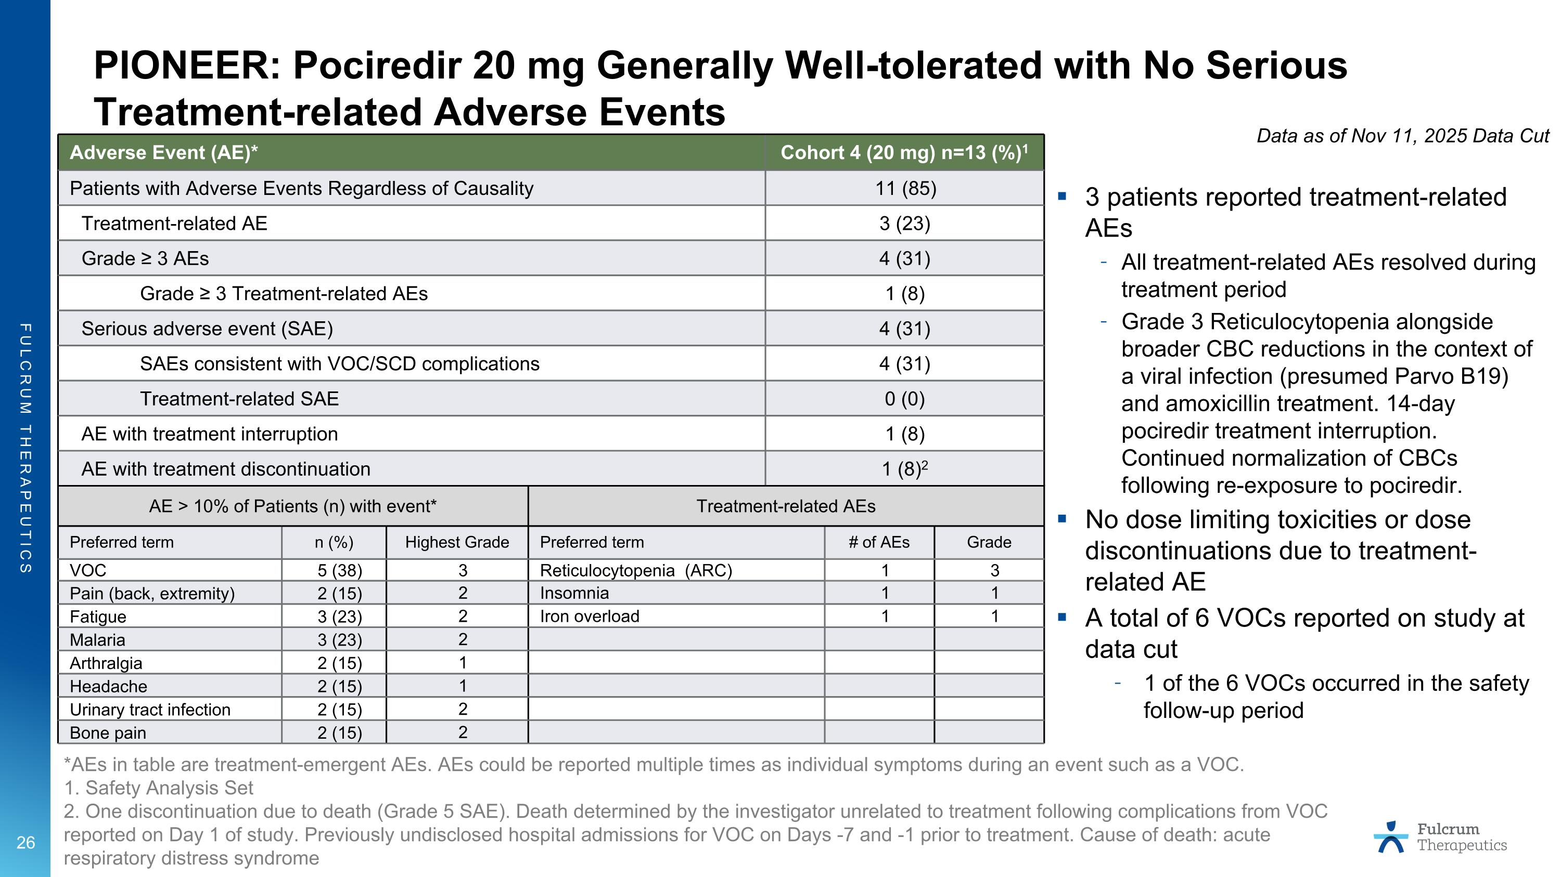
PIONEER: Pociredir 20 mg Generally Well-tolerated with No Serious Treatment-related Adverse Events *AEs in table are treatment-emergent AEs. AEs could be reported multiple times as individual symptoms during an event such as a VOC. 1. Safety Analysis Set 2. One discontinuation due to death (Grade 5 SAE). Death determined by the investigator unrelated to treatment following complications from VOC reported on Day 1 of study. Previously undisclosed hospital admissions for VOC on Days -7 and -1 prior to treatment. Cause of death: acute respiratory distress syndrome AE > 10% of Patients (n) with event* Treatment-related AEs Preferred term n (%) Highest Grade Preferred term # of AEs Grade VOC 5 (38) 3 Reticulocytopenia (ARC) 1 3 Pain (back, extremity) 2 (15) 2 Insomnia 1 1 Fatigue 3 (23) 2 Iron overload 1 1 Malaria 3 (23) 2 Arthralgia 2 (15) 1 Headache 2 (15) 1 Urinary tract infection 2 (15) 2 Bone pain 2 (15) 2 3 patients reported treatment-related AEs All treatment-related AEs resolved during treatment period Grade 3 Reticulocytopenia alongside broader CBC reductions in the context of a viral infection (presumed Parvo B19) and amoxicillin treatment. 14-day pociredir treatment interruption. Continued normalization of CBCs following re-exposure to pociredir. No dose limiting toxicities or dose discontinuations due to treatment-related AE A total of 6 VOCs reported on study at data cut 1 of the 6 VOCs occurred in the safety follow-up period Adverse Event (AE)* Cohort 4 (20 mg) n=13 (%)1 Patients with Adverse Events Regardless of Causality 11 (85) Treatment-related AE 3 (23) Grade ≥ 3 AEs 4 (31) Grade ≥ 3 Treatment-related AEs 1 (8) Serious adverse event (SAE) 4 (31) SAEs consistent with VOC/SCD complications 4 (31) Treatment-related SAE 0 (0) AE with treatment interruption 1 (8) AE with treatment discontinuation 1 (8)2 Data as of Nov 11, 2025 Data Cut

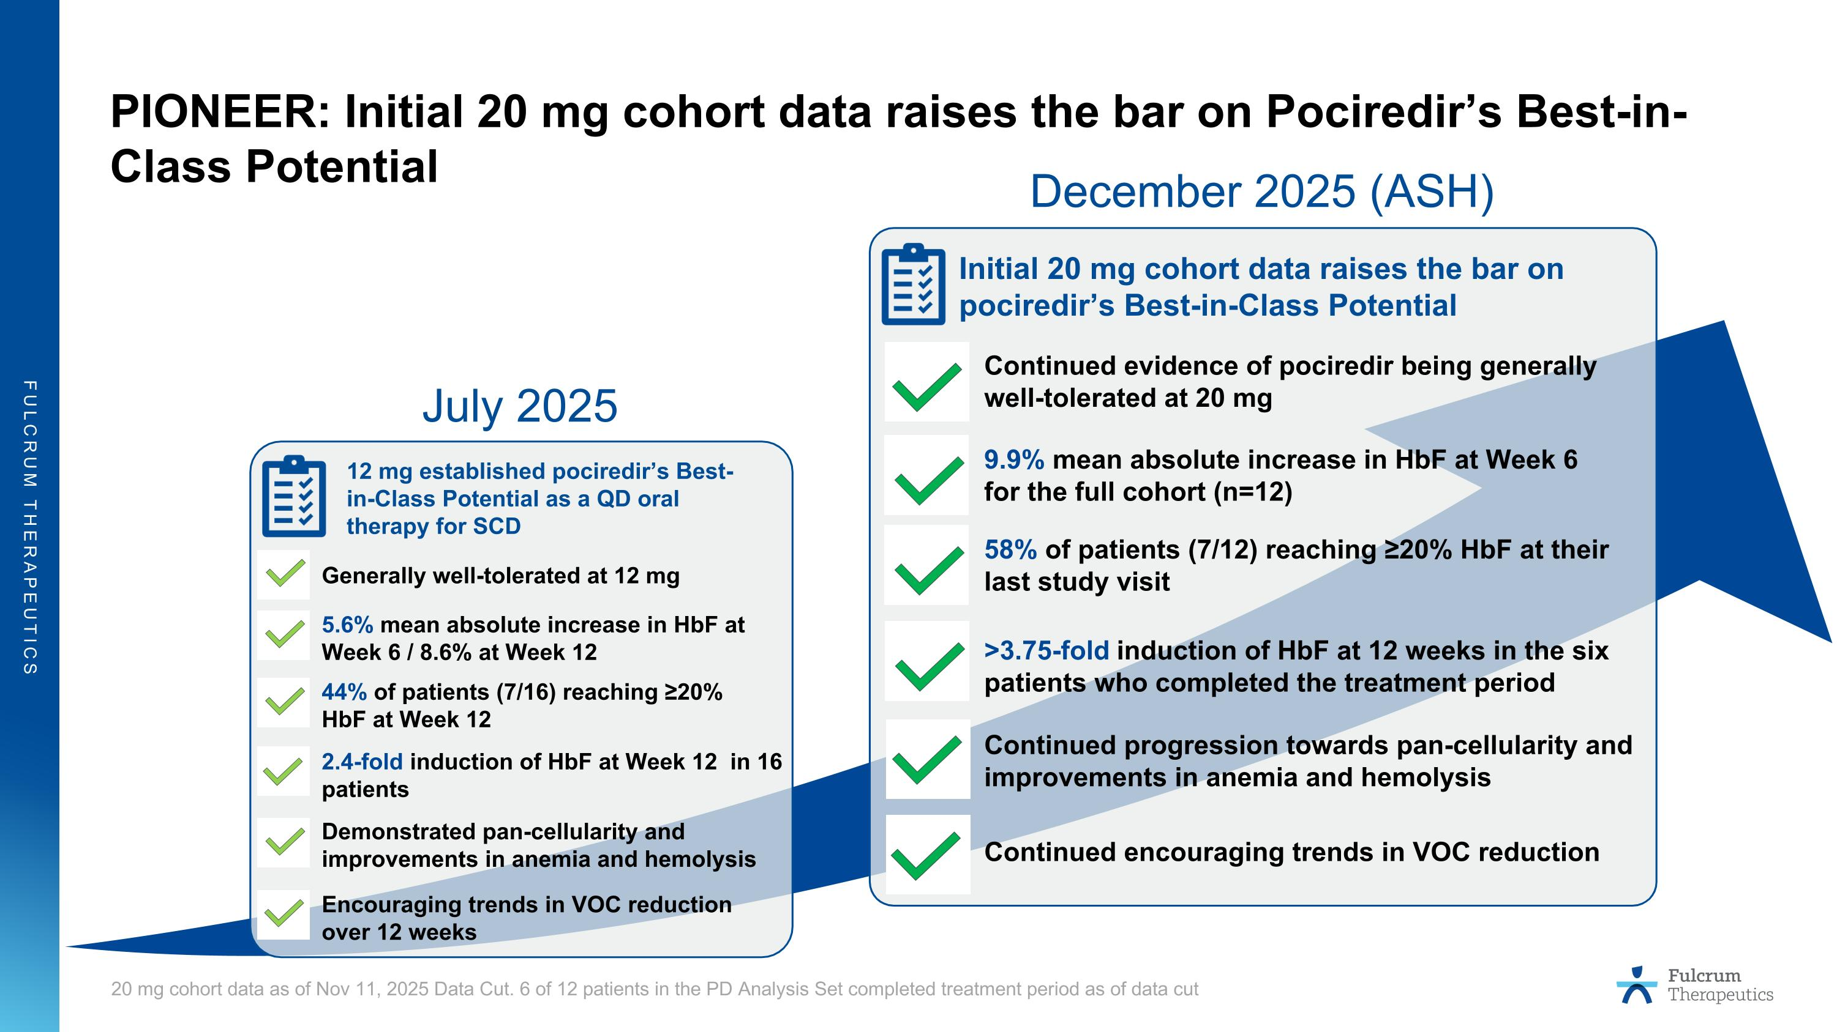
PIONEER: Initial 20 mg cohort data raises the bar on Pociredir’s Best-in-Class Potential 2.4-fold induction of HbF at Week 12 in 16 patients 5.6% mean absolute increase in HbF at Week 6 / 8.6% at Week 12 Demonstrated pan-cellularity and improvements in anemia and hemolysis Encouraging trends in VOC reduction over 12 weeks Generally well-tolerated at 12 mg 12 mg established pociredir’s Best-in-Class Potential as a QD oral therapy for SCD 9.9% mean absolute increase in HbF at Week 6 for the full cohort (n=12) Continued evidence of pociredir being generally well-tolerated at 20 mg Initial 20 mg cohort data raises the bar on pociredir’s Best-in-Class Potential Continued progression towards pan-cellularity and improvements in anemia and hemolysis Continued encouraging trends in VOC reduction >3.75-fold induction of HbF at 12 weeks in the six patients who completed the treatment period 58% of patients (7/12) reaching ≥20% HbF at their last study visit 44% of patients (7/16) reaching ≥20% HbF at Week 12 20 mg cohort data as of Nov 11, 2025 Data Cut. 6 of 12 patients in the PD Analysis Set completed treatment period as of data cut July 2025 December 2025 (ASH)

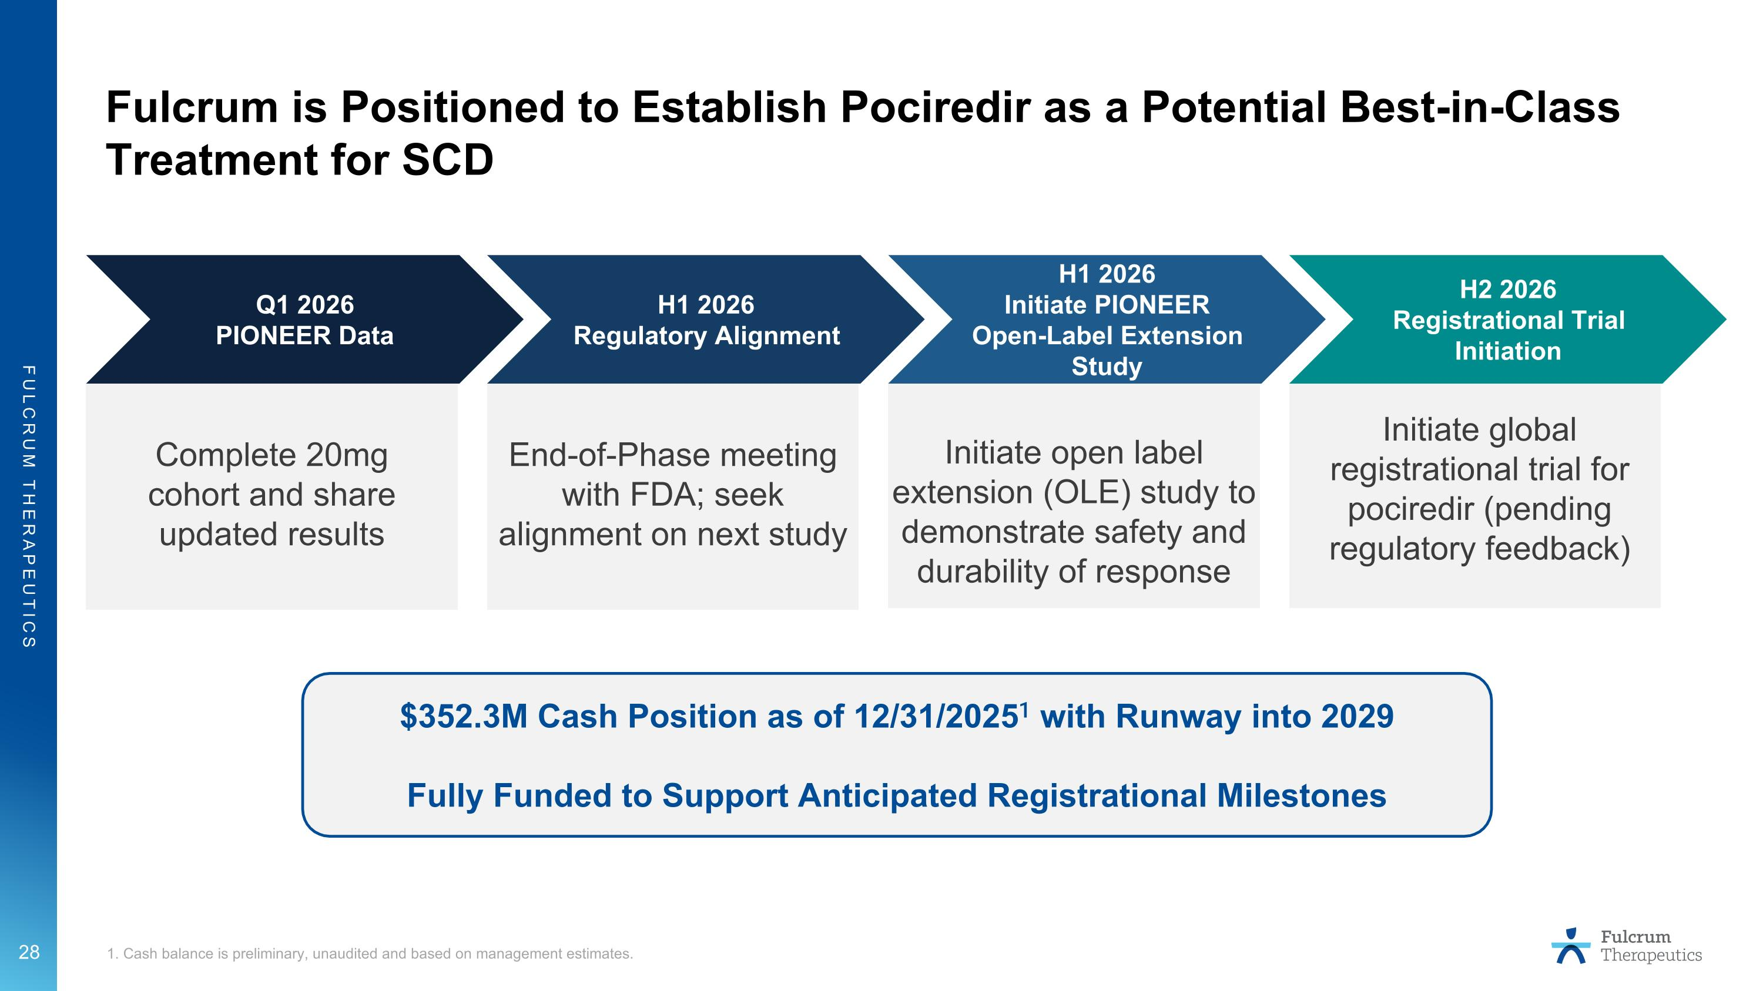
Fulcrum is Positioned to Establish Pociredir as a Potential Best-in-Class Treatment for SCD 1. Cash balance is preliminary, unaudited and based on management estimates. Q1 2026 PIONEER Data Complete 20mg cohort and share updated results H1 2026 Regulatory Alignment End-of-Phase meeting with FDA; seek alignment on next study H1 2026 Initiate PIONEER Open-Label Extension Study Initiate open label extension (OLE) study to demonstrate safety and durability of response H2 2026 Registrational Trial Initiation Initiate global registrational trial for pociredir (pending regulatory feedback) $352.3M Cash Position as of 12/31/20251 with Runway into 2029 Fully Funded to Support Anticipated Registrational Milestones

