Filed by Fulcrum Therapeutics, Inc.
pursuant Rule 425 under the Securities Act of 1933
and deemed filed pursuant to Rule 14a-12
under the Securities Exchange Act of 1934
Subject Company: Fulcrum Therapeutics, Inc.
Filer’s SEC File No.: 001-38978
Date: August 17, 2026
This filing relates to the proposed merger of Fulcrum Therapeutics, Inc., a Delaware corporation (“Fulcrum”), and Slate Medicines, Inc., a Delaware corporation (“Slate”), pursuant to the terms of that certain Agreement and Plan of Meger, dated as of August 16, 2026, by and among Fulcrum, Slate, Fusion Merger Sub I, Inc. and Fusion Merger Sub II, LLC.
On August 17, 2026, Slate published the following communication:

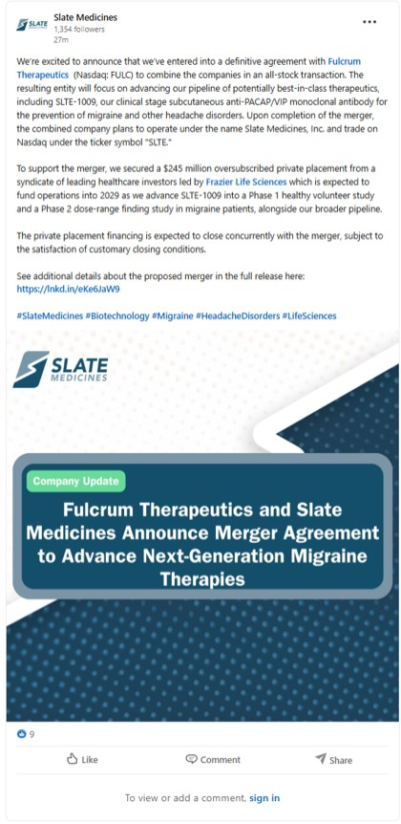
27m We’re excited to announce that we’ve entered into a definitive agreement with Fulcrum Therapeutics (Nasdaq: FULC) to combine the companies in an all-stock transaction. The resulting entity will focus on advancing our pipeline of potentially best-in-class therapeutics, including SLTE-1009, our clinical stage subcutaneous anti-PACAP/VIP monoclonal antibody for the prevention of migraine and other headache disorders. Upon completion of the merger, the combined company plans to operate under the name Slate Medicines, Inc. and trade on Nasdaq under the ticker symbol “SLTE.” To support the merger, we secured a $245 million oversubscribed private placement from a syndicate of leading healthcare investors led by Frazier Life Sciences which is expected to fund operations into 2029 as we advance SLTE-1009 into a Phase 1 healthy volunteer study and a Phase 2 dose-range finding study in migraine patients, alongside our broader pipeline. The private placement financing is expected to close concurrently with the merger, subject to the satisfaction of customary closing conditions. See additional details about the proposed merger in the full release here: https:// lnkd.in/eKe6JaW9 #SlateMedicines #Biotechnology #Migraine #HeadacheDisorders #lifeSciences

Forward-Looking Statements
This communication and the documents filed as exhibits hereto contain forward-looking statements within the meaning of the U.S. Private Securities Litigation Reform Act of 1995, including statements regarding the proposed transaction involving Fulcrum and Slate, including the conditions to, and timing of, closing of the proposed transaction, the Board of Directors and management of the combined company, the percentage ownership of the combined company (which is subject to adjustment based on the amount of Fulcrum’s net cash as of the closing of the proposed transaction), the potential of Fulcrum stockholders to receive cash distributions (including the amount thereof), the parties’ ability to consummate the proposed transaction and Slate private placement financing, including the intended use of net proceeds from the Slate private placement financing and the expected timing of closing and completion of the private placement financing, the combined company’s expected cash runway and the sufficiency of the combined company’s cash to fund operations into 2029, the listing of the combined company’s shares on Nasdaq, the expectations surrounding the potential, safety, efficacy, and regulatory and clinical progress of Slate’s product candidates, including SLTE-1009, and anticipated milestones and timing, among others.
Forward-looking statements generally include statements that are predictive in nature and depend upon or refer to future events or conditions, and include words such as “may,” “will,” “should,” “would,” “expect,” “anticipate,” “plan,” “likely,” “believe,” “estimate,” “project,” “intend,” and other similar expressions among others. Statements that are not historical facts are forward-looking statements. Forward-looking statements are based on current beliefs and assumptions that are subject to risks and uncertainties and are not guarantees of future performance. Actual results could differ materially from those contained in any forward-looking statement as a result of various factors, including, without limitation, risks with respect to: (i) the timely satisfaction of the conditions to the closing of the proposed transaction, including the failure to timely or at all obtain stockholder approval for the proposed transaction or the failure to timely or at all obtain any required regulatory clearances; (ii) uncertainties as to the timing of the consummation of the proposed transaction and the ability of each of Fulcrum and Slate to consummate the proposed transaction; (iii) the ability of Fulcrum and Slate to integrate their businesses successfully and to achieve anticipated synergies; (iv) the possibility that other anticipated benefits of the proposed transaction will not be realized, including without limitation, anticipated revenues, expenses, earnings and other financial results, and growth and expansion of the combined company’s operations, and the anticipated tax treatment of the combination; (v) potential litigation relating to the proposed transaction that could be instituted against Fulcrum, Slate or their respective directors; (vi) possible disruptions from the proposed transaction that could harm Fulcrum’s and/or Slate’s respective businesses; (vii) the ability of Slate to retain, attract and hire key personnel; (viii) potential adverse reactions or changes to relationships with employees, suppliers or other parties resulting from the announcement or completion of the proposed transaction; (ix) potential business uncertainty, including changes to existing business relationships, during the pendency of the proposed transaction that could affect Fulcrum’s or Slate’s financial performance; (x) certain restrictions during the pendency of the proposed transaction that may impact Fulcrum’s or Slate’s ability to pursue certain business opportunities or strategic transactions; (xi) the combined company’s need for additional funding, which may not be available on favorable terms or at all; (xii) potential failure to identify additional product candidates and develop or commercialize marketable products; (xiii) the early stage of the combined company’s development efforts; (xiv) potential unforeseen events during clinical trials could cause delays or other adverse consequences; (xv) risks relating to the regulatory approval process; (xvi) interim, topline and preliminary data may change as more patient data become available, and are subject to audit and verification procedures that could result in material changes in the final data; (xvii) the combined company’s product candidates may cause serious adverse side effects; (xviii) inability to maintain existing or future collaborations, or the failure of these collaborations; (xix) the combined company’s reliance on third parties, including for the manufacture of materials for research programs, preclinical and clinical studies; (xx) failure to obtain U.S. or international marketing approval; (xxi) ongoing regulatory obligations; effects of significant competition; (xxii) unfavorable pricing regulations, third-party reimbursement practices or healthcare reform initiatives; (xxiii) product liability lawsuits; (xxiv) securities class action litigation; (xxv) the impact of general economic conditions on their respective business and operations, including the combined company’s preclinical studies and clinical trials; (xxvi) the possibility of system failures or security breaches; risks relating to intellectual property; (xxvii) significant costs incurred as a result of operating as a public company; (xxviii) the risk that, as a result of adjustments to the exchange ratio, Fulcrum stockholders and Slate stockholders could own less of the combined company than is currently anticipated, including as a result of the determination of Fulcrum’s net cash; (xxix) risks related to the market price of Fulcrum’s common stock relative to the value implied by the exchange ratio; (xxx) the risk that the concurrent private placement financing is not consummated; and (xxxi) such other

factors as are set forth in Fulcrum’s periodic public filings with the SEC, including but not limited to those described under the heading “Risk Factors” in Fulcrum’s Quarterly Report on Form 10-Q for the period ended June 30, 2026. Fulcrum and Slate can give no assurance that any or all of the conditions to the proposed transaction will be satisfied. Except as required by applicable law, Fulcrum and Slate undertake no obligation to revise or update any forward-looking statement, or to make any other forward-looking statements, whether as a result of new information, future events or otherwise.
No Offer or Solicitation
This communication and the information contained herein is not intended to and does not constitute (i) a solicitation of a proxy, consent or approval with respect to any securities or in respect of the proposed merger or (ii) an offer to sell or the solicitation of an offer to subscribe for or buy or an invitation to purchase or subscribe for any securities pursuant to the proposed merger or otherwise, nor shall there be any sale, issuance or transfer of securities in any jurisdiction in contravention of applicable law. No offer of securities shall be made except by means of a prospectus meeting the requirements of the Securities Act of 1933, as amended, or an exemption therefrom. Subject to certain exceptions to be approved by the relevant regulators or certain facts to be ascertained, the public offer will not be made directly or indirectly, in or into any jurisdiction where to do so would constitute a violation of the laws of such jurisdiction, or by use of the mails or by any means or instrumentality (including without limitation, facsimile transmission, telephone and the internet) of interstate or foreign commerce, or any facility of a national securities exchange, of any such jurisdiction.
NEITHER THE SEC NOR ANY STATE SECURITIES COMMISSION HAS APPROVED OR DISAPPROVED OF THE SECURITIES OR DETERMINED IF THIS COMMUNICATION IS TRUTHFUL OR COMPLETE.
Additional Information and Where to Find It
This communication is not a substitute for the registration statement or for any other document that Fulcrum may file with the SEC in connection with the proposed merger. In connection with the proposed merger between Fulcrum and Slate, Fulcrum intends to file relevant materials with the SEC, including a registration statement on Form S-4 that will contain a proxy statement/prospectus of Fulcrum. FULCRUM URGES INVESTORS AND STOCKHOLDERS TO READ THE REGISTRATION STATEMENT, PROXY STATEMENT/PROSPECTUS AND ANY OTHER RELEVANT DOCUMENTS THAT MAY BE FILED WITH THE SEC, AS WELL AS ANY AMENDMENTS OR SUPPLEMENTS TO THESE DOCUMENTS, CAREFULLY AND IN THEIR ENTIRETY IF AND WHEN THEY BECOME AVAILABLE BECAUSE THEY WILL CONTAIN IMPORTANT INFORMATION ABOUT FULCRUM, SLATE, THE PROPOSED MERGER AND RELATED MATTERS. Investors and stockholders will be able to obtain free copies of the proxy statement/prospectus and other documents filed by Fulcrum with the SEC (when they become available) through the website maintained by the SEC at www.sec.gov. Stockholders are urged to read the proxy statement/prospectus and the other relevant materials when they become available before making any voting or investment decision with respect to the proposed merger. In addition, investors and stockholders should note that Fulcrum communicates with investors and the public using its website (ir.fulcrumtx.com).
Participants in the Solicitation
Fulcrum, Slate and their respective directors and executive officers may be deemed to be participants in the solicitation of proxies from stockholders in connection with the proposed merger. Information about Fulcrum’s directors and executive officers, including a description of their interests in Fulcrum, is included in Fulcrum’s definitive proxy statement on Schedule 14A for its 2026 Annual Meeting of Stockholders as filed with the SEC, and in filings by such individuals on Form 4. Additional information regarding these persons and their interests in the transaction will be included in the proxy statement/prospectus relating to the proposed merger when it is filed with the SEC. These documents can be obtained free of charge from the sources indicated above.

